Audi Eyes

Ayoub Maimmadi

# 1. Project Inception

## 1.1. Framing the Business Idea as an ML Problem

* Business case description

Audieyes is a pioneering project applying cutting-edge machine learning technology to improve visually impaired people’s quality of life and safety. It uses image and video captioning technology to provide immediate, comprehensive descriptions of surroundings and objects, virtually addressing accessibility or navigation issues. However, the software is a response to a severe problem that has received little attention from the massively underrepresented assistive programs market; it can have an enormous social and business impact. Audieyes technology helps companies enter new markets while ensuring its users get a massive improvement in their quality of life. Find more details here. For more details click [here](https://github.com/AyoubMaimmadi/Audieyes?tab=readme-ov-file#business-case).

* Business value of using ML

Machine learning can enhance the quality and customize recognition of the visual data. Such a possibility will promote the service in its capacity to help the visually impaired. Because of ML, the precise and fast captioning of the images and videos will be possible, providing real-time feedback required for an improved experience of navigation and interaction. Additionally, learning through usage and feedback modifications the service’s effectiveness, ensuring that the technology advances to fill all needs of different users. As a result, the users become dependent and more satisfied with the service, while the company becomes a leader in the innovation of similar technologies and extends market shares. Therefore, more users are likely to purchase the additional technology, ensuring the revenue streams. For more details click [here](https://github.com/AyoubMaimmadi/Audieyes?tab=readme-ov-file#business-value-of-using-ml).

* Data overview

Audieyes uses a large dataset consisting of image-text pairs obtained from COCO, flickr30k, vqa, and nlvr. This diverse set of information and illustrative situation scenarios are specifically important as it allows for more effective training of the ML models to better interpret and verbalize the image contents. The actual data refers specifically to common objects, people, sceneries, and actions, which guarantees the broad coverage and practical relevance of the encounters the visually impaired may expect. Such a broad data foundation ensures the contextual and semantic relevancy of the captions produced by the ML models, which is essential for the effective performance of the Audieyes system. For More details click [here](https://github.com/AyoubMaimmadi/Audieyes?tab=readme-ov-file#data-sources).

|  |  |  |
| --- | --- | --- |
| Model checkpoints | Dataset trained on | Pretrained model |
| model_base.pth | N/A | N/A |
| model_base_nlvr.pth | https://storage.googleapis.com/sfr-vision-language-research/datasets/nlvr_train.json | https://storage.googleapis.com/sfr-vision-language-research/BLIP/models/model_base_nlvr.pth |
| model_base_retrieval_coco.pth | https://storage.googleapis.com/sfr-vision-language-research/datasets/coco_karpathy_train.json | https://storage.googleapis.com/sfr-vision-language-research/BLIP/models/model_base_retrieval_coco.pth |
| model_vqa.pth | https://storage.googleapis.com/sfr-vision-language-research/datasets/vqa_train.json | https://storage.googleapis.com/sfr-vision-language-research/BLIP/models/model_base_vqa_capfilt_large.pth |
| model_base_retrieval_flickr.pth | https://storage.googleapis.com/sfr-vision-language-research/datasets/flickr30k_train.json | https://storage.googleapis.com/sfr-vision-language-research/BLIP/models/model_base_retrieval_flickr.pth |

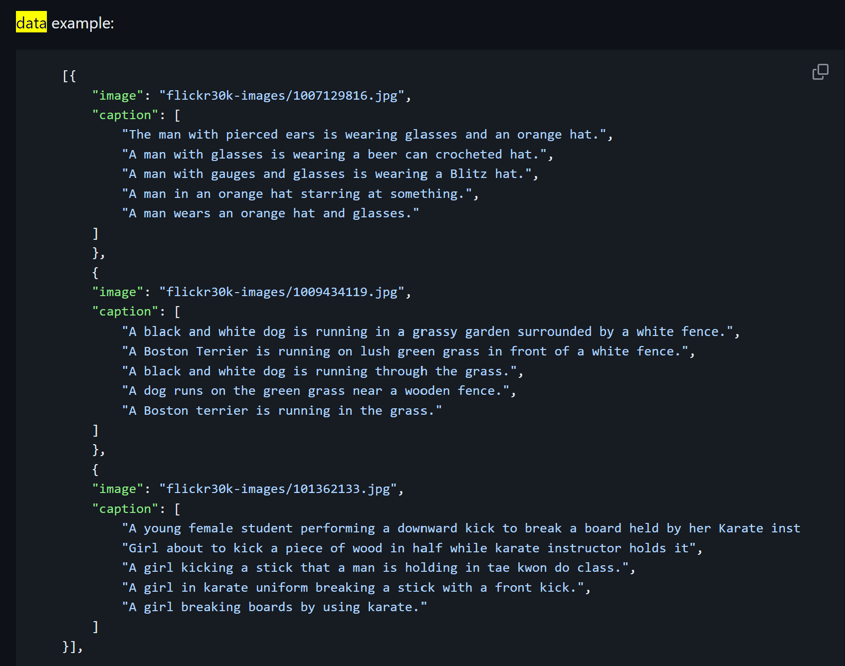

* Project archetype

Audieyes represents a hybrid of autonomous real-time systems and human-in-the-loop architectures. It combines the speed and scalability of automated machine learning for instant image and video captioning with the precision of human oversight to enhance accuracy and contextual relevance. This model ensures that the system can operate independently while still benefiting from periodic human intervention to refine outputs, making it highly effective for applications in dynamic and varied environments. The design caters specifically to the needs of the visually impaired, promoting independence through technology while maintaining the flexibility to adapt and improve with user feedback. For more details click [here](https://github.com/AyoubMaimmadi/Audieyes?tab=readme-ov-file#architectural-archetypes-for-vision-captioning).

## 1.2. Feasibility analysis

* + literature review

The development of "Audieyes" is underpinned by significant advancements in machine learning, particularly in the fields of image and video processing that cater to enhancing accessibility for visually impaired individuals. This literature review examines the relevant technologies and models that form the basis of the Audieyes project, focusing on their applicability and effectiveness in real-world scenarios.

1. **. Machine Learning Models for Image and Video Captioning**
   1. **. Salesforce's BLIP Model:**

The BLIP (Bootstrapped Language Image Pretraining) model from Salesforce is a cornerstone in the image captioning domain, known for its efficacy in generating accurate and contextually relevant descriptions from images. BLIP’s architecture is designed to leverage large-scale datasets combining images with textual annotations, which is ideal for the diverse inputs expected in Audieyes. This model's proven capabilities in visual question answering and image captioning provide a reliable foundation for developing Audieyes’ core functionalities.

* 1. **. Moondream:**

Moondream is a compact, open-source computer vision model characterized by its portability and efficiency. Its design allows it to run on a wide range of devices, making it particularly suitable for real-time applications in accessibility technologies. The model’s robust performance in various settings demonstrates its potential to be integrated into Audieyes, ensuring that the application is both scalable and adaptable across different hardware environments.

* 1. **. Hugging Face’s Vit-GPT2 Image Captioning:**

Hosted on the Hugging Face platform, the Vit-GPT2 model combines vision-transformer (ViT) and GPT-2 technologies to create a potent image-to-text system. This model excels in translating visual data into descriptive text, a key feature for Audieyes. The use of transformer architectures allows for nuanced understanding and generation of captions, which can significantly enhance the user experience for the visually impaired by providing detailed and accurate descriptions of their surroundings.

* + Model choice/ specification of a baseline

For the Audieyes project, I have chosen the BLIP (Bootstrapping Language-Image Pre-training) model as our baseline due to its comprehensive abilities in both vision-language understanding and generation, which are essential for real-time image and video captioning applications aimed at assisting visually impaired users.

**Key Features and Specifications of BLIP:**

**Architecture:** BLIP employs a Multimodal Mixture of Encoder-Decoder (MED) architecture, which is versatile in functioning as a unimodal encoder, an image-grounded text encoder, or an image-grounded text decoder. This flexibility allows it to adaptively handle various tasks, including image captioning and text retrieval, within the same framework.

**Pre-training Methodology:** BLIP uses a novel dataset bootstrapping technique, CapFilt, which involves generating synthetic captions for web images and filtering out noisy ones. This method improves the quality of training data, especially considering the prevalent noise in web-crawled datasets.

**Performance Metrics:**

**Image-text retrieval:** Improved recall@1 by +2.7% on average.

**Image captioning:** Enhanced CIDEr scores by +2.8%.

**Visual Question Answering (VQA):** Increased VQA score by +1.6%.

**Generalization:** BLIP demonstrates strong zero-shot generalization to video-language tasks, which could be beneficial for extending Audieyes to video captioning in the future.

**Advantages for Audieyes:**

**High Relevance and Accuracy:** BLIP's capability to generate contextually relevant captions directly supports the core functionality of Audieyes, enhancing the user's understanding of their surroundings.

**Scalability and Flexibility:** The model’s architecture and the CapFilt training approach allow for easy scalability and adaptation to various data environments, crucial for deployment across different geographic locations.

* + Metrics for business goal evaluation

To effectively measure the success and impact of the Audieyes project, it is essential to establish clear, quantifiable metrics that align with the business objectives and operational goals. The following metrics have been identified to evaluate the performance and business value of Audieyes:

**1. User Engagement Metrics:**

**. Daily Active Users (DAU) and Monthly Active Users (MAU):** These metrics will help track the usage frequency and retention of the application, providing insights into its acceptance and value to users.

**. Session Length:** Measures the average duration users interact with the app per session, indicating the application's utility and user reliance.

**2. Performance Metrics:**

**. Caption Accuracy:** Accuracy of the image and video captions generated by the BLIP model, assessed through human validation or comparison with benchmark datasets.

**. System Latency:** Time taken from image/video input to caption output, crucial for real-time performance. A lower latency ensures a seamless experience for users.

**3. Customer Satisfaction Metrics:**

**. Net Promoter Score (NPS):** This metric gauge’s user satisfaction and likelihood to recommend Audieyes to others, which is pivotal for organic growth in the consumer base.

**. User Feedback and Reviews:** Qualitative assessments from users, providing insights into the app's impact on their daily lives and areas needing improvement.

**4. Accessibility Impact Metrics:**

**. Tasks Completed:** The number of tasks users successfully complete with the aid of Audieyes, such as navigation in new environments or identification of objects.

**. Incidence of Accessibility Issues:** Tracking issues reported by users related to accessibility, helping to refine and enhance the app’s functionality.

**5. Economic Metrics:**

**. Customer Acquisition Cost (CAC):** The cost associated with acquiring a new customer, essential for evaluating the efficiency of marketing strategies.

**. Lifetime Value (LTV):** The total revenue expected from a typical customer over the life of their relationship with the app, indicating the long-term viability of the project.

# 2. ML Pipeline Development - From a Monolith to a Pipeline

## 2.1. Ensuring ML Pipeline Reproducibility

* Project structure definition and modularity

The Audieyes project is organized into a modular architecture to optimize scalability, minimize maintenance costs, and promote development team cooperation. This model comprises several layers: the Kubernetes Layer for managing container orchestration, ensuring scalability and high availability; the App Layer containing both backend application logic and the frontend interface; the Docker Layer handling containerization for consistent environments across development, testing, and production; the Models Layer including machine learning models such as the baseline BLIP model; the Notebooks Layer for data exploration and model development; the References Layer for storing reference materials and documentation; and the ZenML Layer managing the ML pipeline, including data ingestion, preprocessing, training, evaluation, and deployment processes. Each layer operates as an independent module with clearly defined interfaces for communication, allowing for separate updates and replacements. This structure supports parallel development, enhances productivity, simplifies testing and maintenance, and promotes reusability for future projects. Overall, this modular pipeline guarantees the reliability and reproducibility of Audieyes while preparing the system for future growth and meeting the project's long-term ambitions.

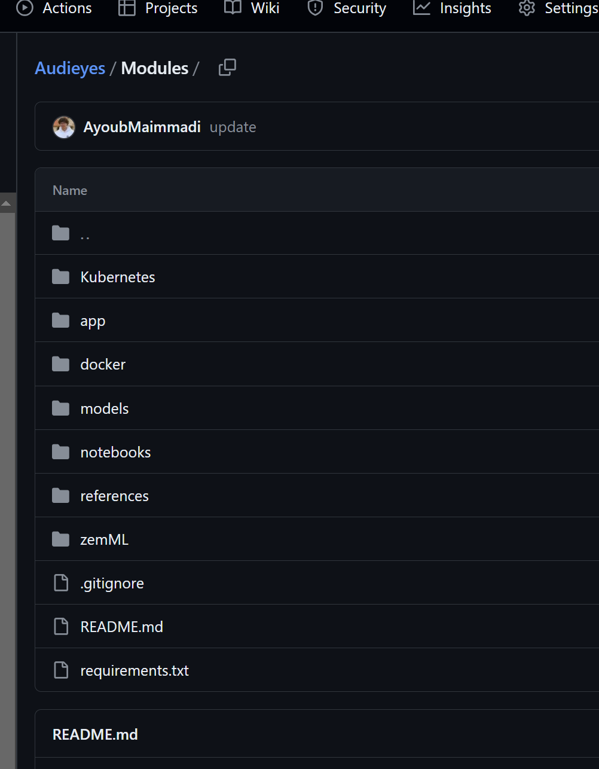

To sum up, the described approach to building a structured, modular pipeline guarantees the reliability and reproducibility for the Audieyes, while also preparing the system for further growth, meeting the project’s overarching goals and long-term ambitions.

* Code Versioning

GitHub and Docker Hub are used for maintaining robust code versioning and management for the Audieyes project. GitHub is the main repository for all of the project codes including the application logic, machine learning models, and system configurations. It enables version control to keep track of all the changes, revert to the older state, and maintain branches for issue tracking, feature development, or bug fixing. It also enables collaborative features such as PR and code review to maintain the quality and uniformity of the codebase across the development cycle. On the other hand, Docker Hub is used for managing the Docker images of the project. It enables our development pipeline to produce consistent environments throughout each stage from development to production. The Docker images are managed with versioning on Docker Hub so that anyone from the team or the CI/CD pipeline can pull the right version of the environment to run the application without any hassle. Thus, it enables the reusability of the environment and reduces the “works on my machine” situation. View the repo [here](https://github.com/AyoubMaimmadi/Audieyes/blob/main/Modules/zemML/pipelines/validation/greate_expectation_validation.ipynb).

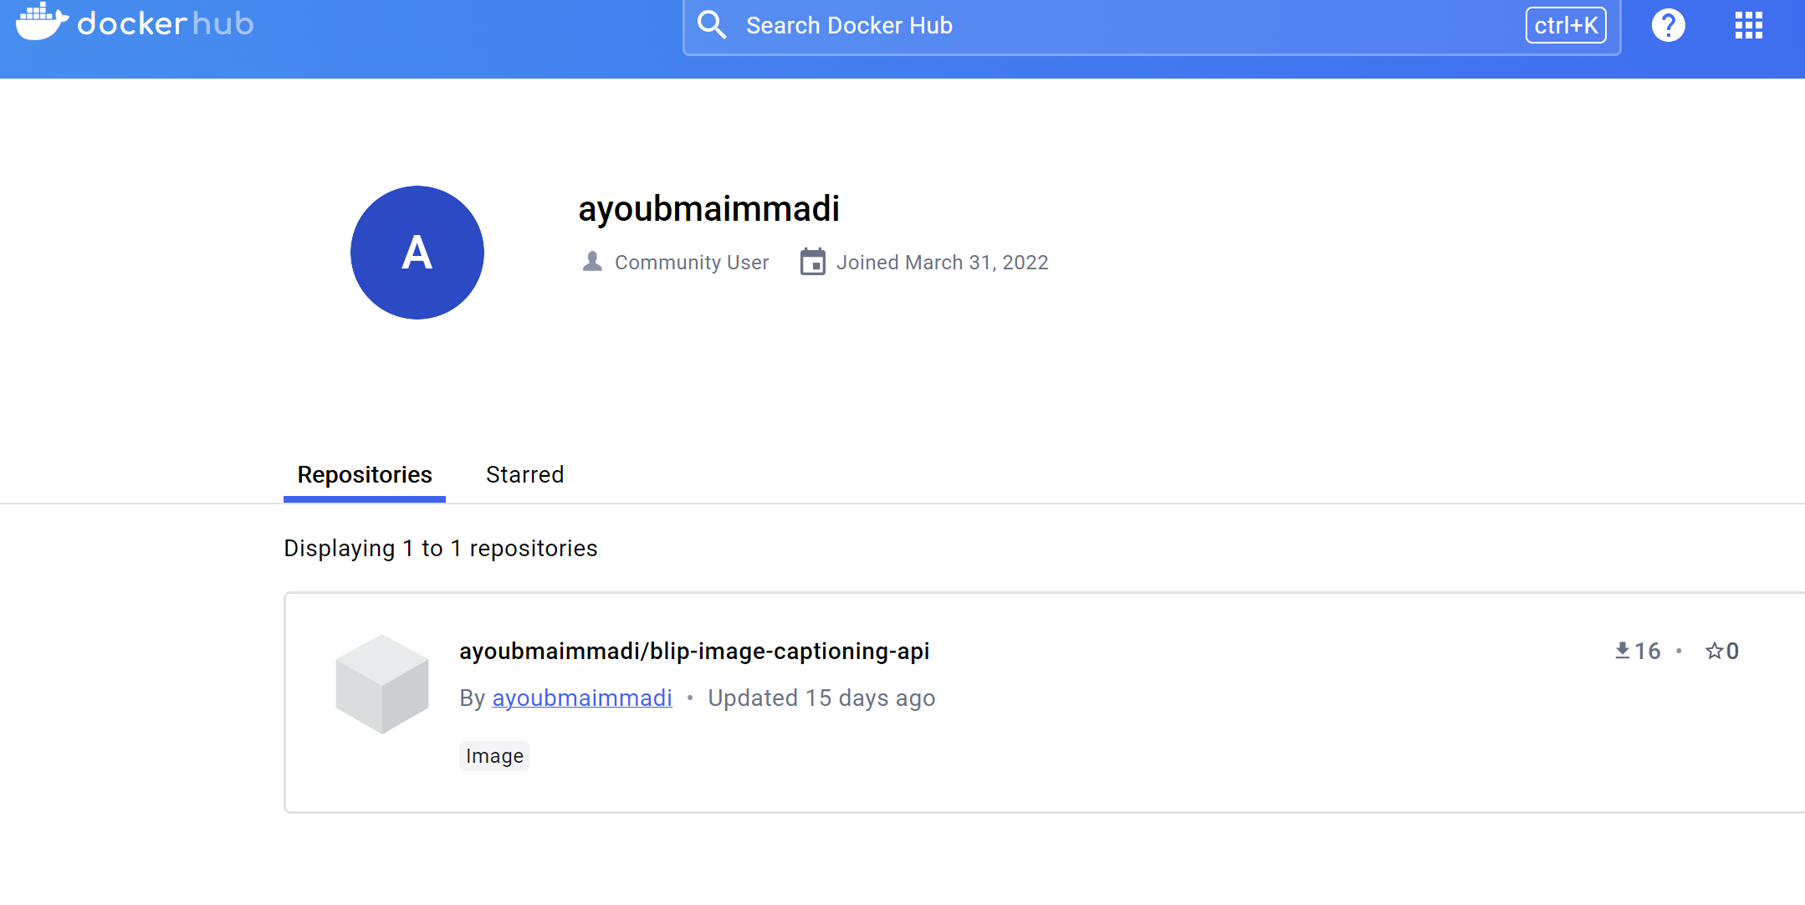

* Data versioning

Data versioning in the Audieyes project is managed through Data Version Control (DVC), ensuring the integrity and reproducibility of the machine learning pipeline. DVC tracks versions of datasets and models, allowing every experiment to be reproduced and every training session to be traced back to its data source. Unlike Git, DVC efficiently handles large data files and machine learning models. It tracks dataset changes like source code, vital for debugging, improving models, and maintaining consistency across team collaborations. I have connected my DVC with google storage:

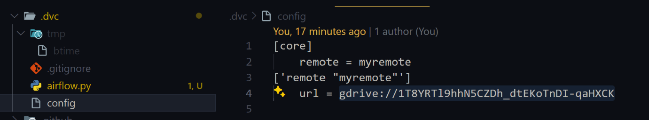

And then i connected DVC and ML MLflow via Airflow to move data from DVC to MLflow. Here is the setup: 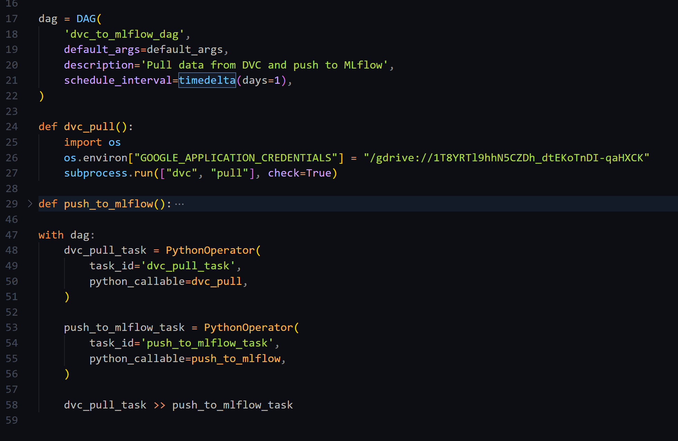

* Experiment tracking and model versioning

Critical components in managing the machine learning lifecycle effectively. MLflow offers a centralized platform to monitor experiments, including tracking of parameters, metrics, and model artifacts across various stages of the ML pipeline. This functionality allows our team to compare different model versions objectively, facilitating the identification of the most effective configurations based on empirical data.

Model versioning in MLflow provides a systematic way to version and store models, ensuring that every iteration is cataloged and retrievable. This capability is crucial for rolling back to previous versions if needed and for auditing purposes, allowing us to maintain a detailed history of model development and changes over time.

I have successfully loaded 5 model checkpoints to MLflow and was able to run experiments to compare between these models.

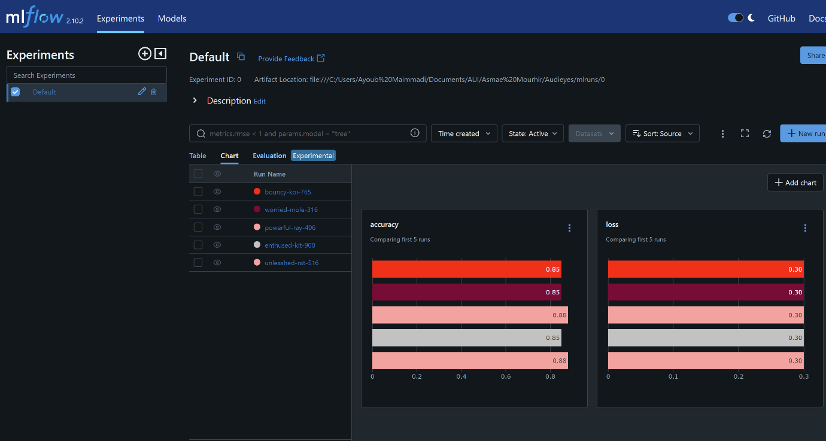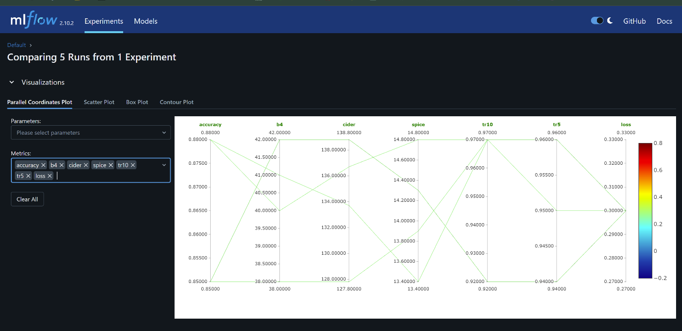

By integrating MLflow, the Audieyes project benefits from enhanced reproducibility and accountability in model development, enabling seamless transitions between model iterations and ensuring consistent results in deployment environments. This setup not only streamlines the development process but also supports robust testing and deployment strategies, crucial for delivering a reliable assistive technology solution.

* Setting up a meta store for metadata

In the Audieyes project, we've integrated Great Expectations for data validation and Cassandra for storing and retrieving features. The use of Great Expectations ensures the integrity and quality of data, while Cassandra manages feature storage, facilitating seamless access and analysis of metadata across the project's lifecycle. This setup enhances the reproducibility of our ML pipeline and enables effective tracking of experiments and model versions, which is crucial for maintaining consistency and accelerating development cycles in our Audieyes system. For more details click [here](https://github.com/AyoubMaimmadi/Audieyes?tab=readme-ov-file#experiment--metadata-tracking-with-mlflow).

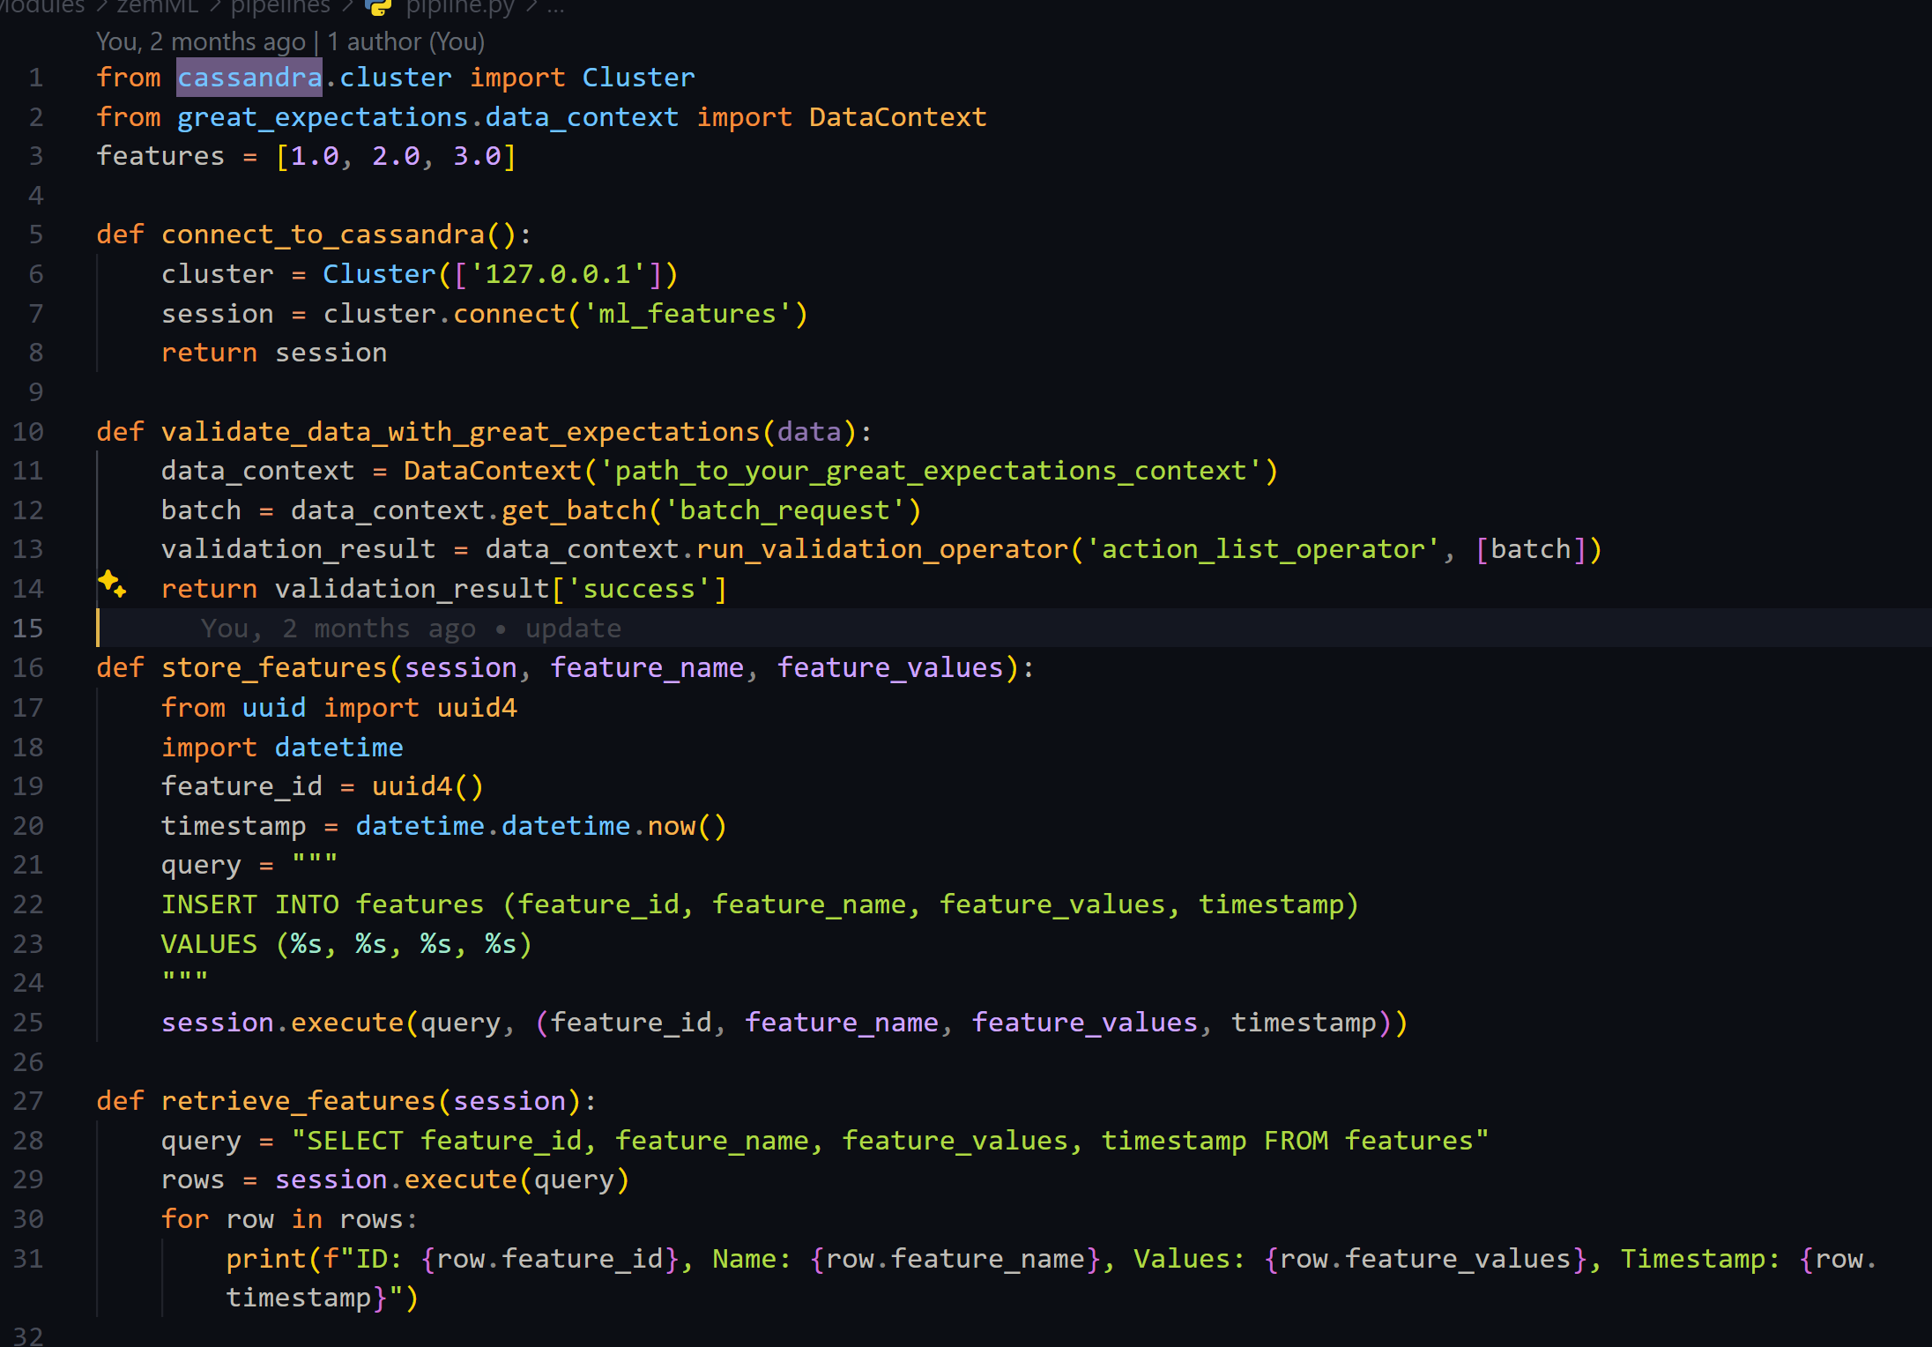

* Setting up the machine learning pipeline under an MlOps platform

In the Audieyes project, I have set up the machine learning pipeline using ZenML, an open-source MLOps framework that enhances the entire ML lifecycle from data ingestion to model deployment. ZenML supports our goals of developing and testing the ML pipeline with a structured and scalable approach, emphasizing reproducibility, collaboration, and automation. Key components of our pipeline include data validation to ensure input data integrity,

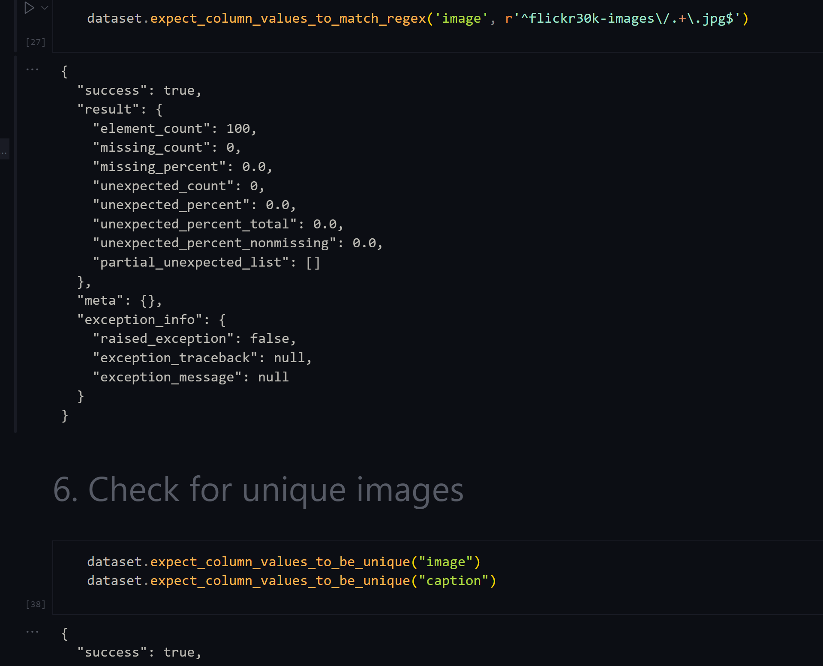 data ingestion from diverse JSON sources, and data splitting to effectively segregate data into training and validation sets.

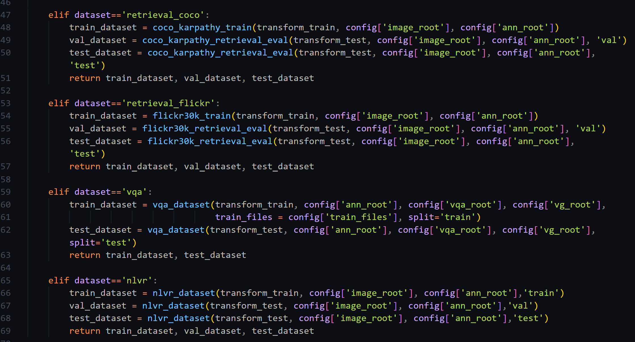

ZenML will automatically run all pipeline scripts one after the other and provide logs and details about the progress in their dashboard.

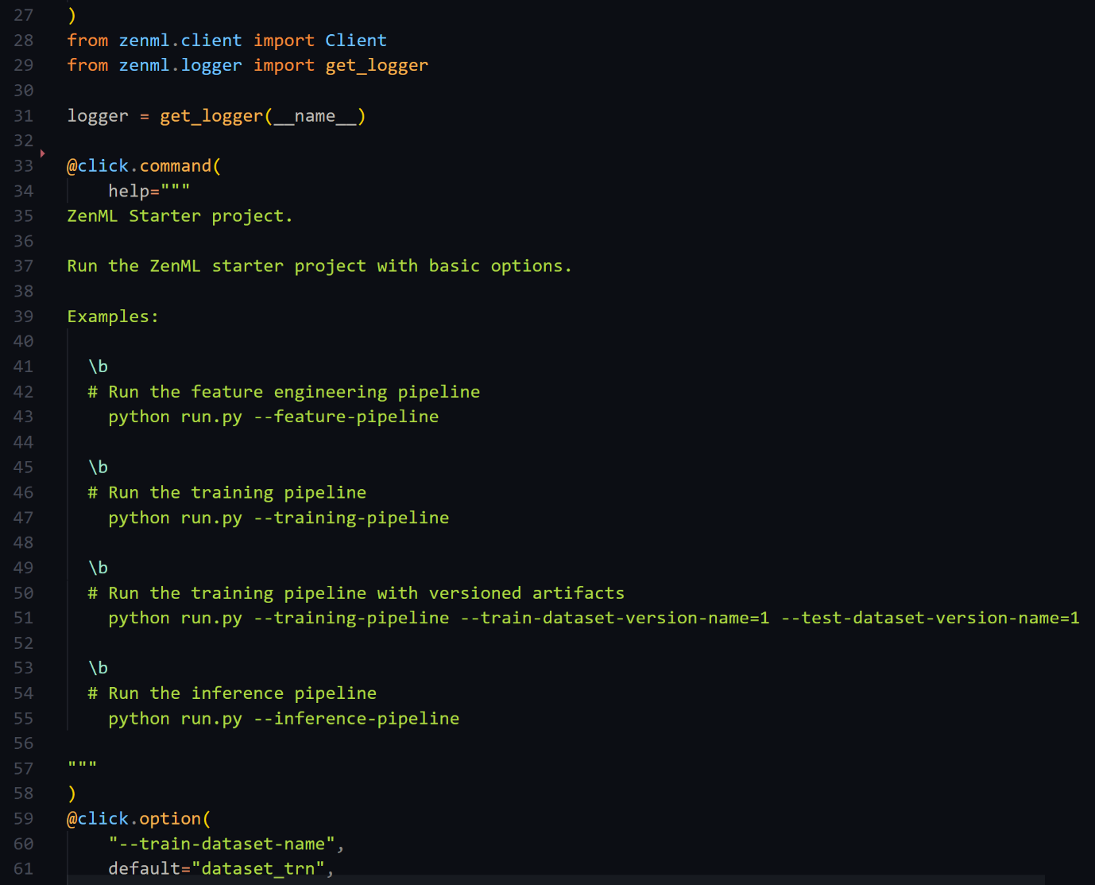

## 2.2. Pipeline Components

* + 1. Setup of data pipeline within the larger ML pipeline/ MLOps Platform
  + Data Validation and Verification

For the Audieyes project, an integral component of our ML pipeline setup within the MLOps platform is the robust process of Data Validation and Verification. I utilize the library Great Expectations, which plays a critical role in ensuring the integrity and quality of data flowing through our pipeline. This tool allows us to implement comprehensive data checks, including schema validation, data type verification, and constraint checks, which help prevent data corruption and inconsistencies that could adversely affect model training and performance.

Great Expectations enables us to automate the validation process, providing a structured framework to define and verify expectations for data quality. This setup helps maintain a high standard of data quality from the ingestion phase through to model training, making our ML pipeline more reliable and efficient. By embedding Great Expectations into our data pipeline, I ensure that all data meets the predefined criteria before it is processed, enhancing the reliability of our ML outputs and ensuring that the Audieyes project delivers accurate and impactful results to the end-users. View details [here](https://github.com/AyoubMaimmadi/Audieyes/blob/main/Modules/zemML/pipelines/validation/greate_expectation_validation.ipynb).

\ 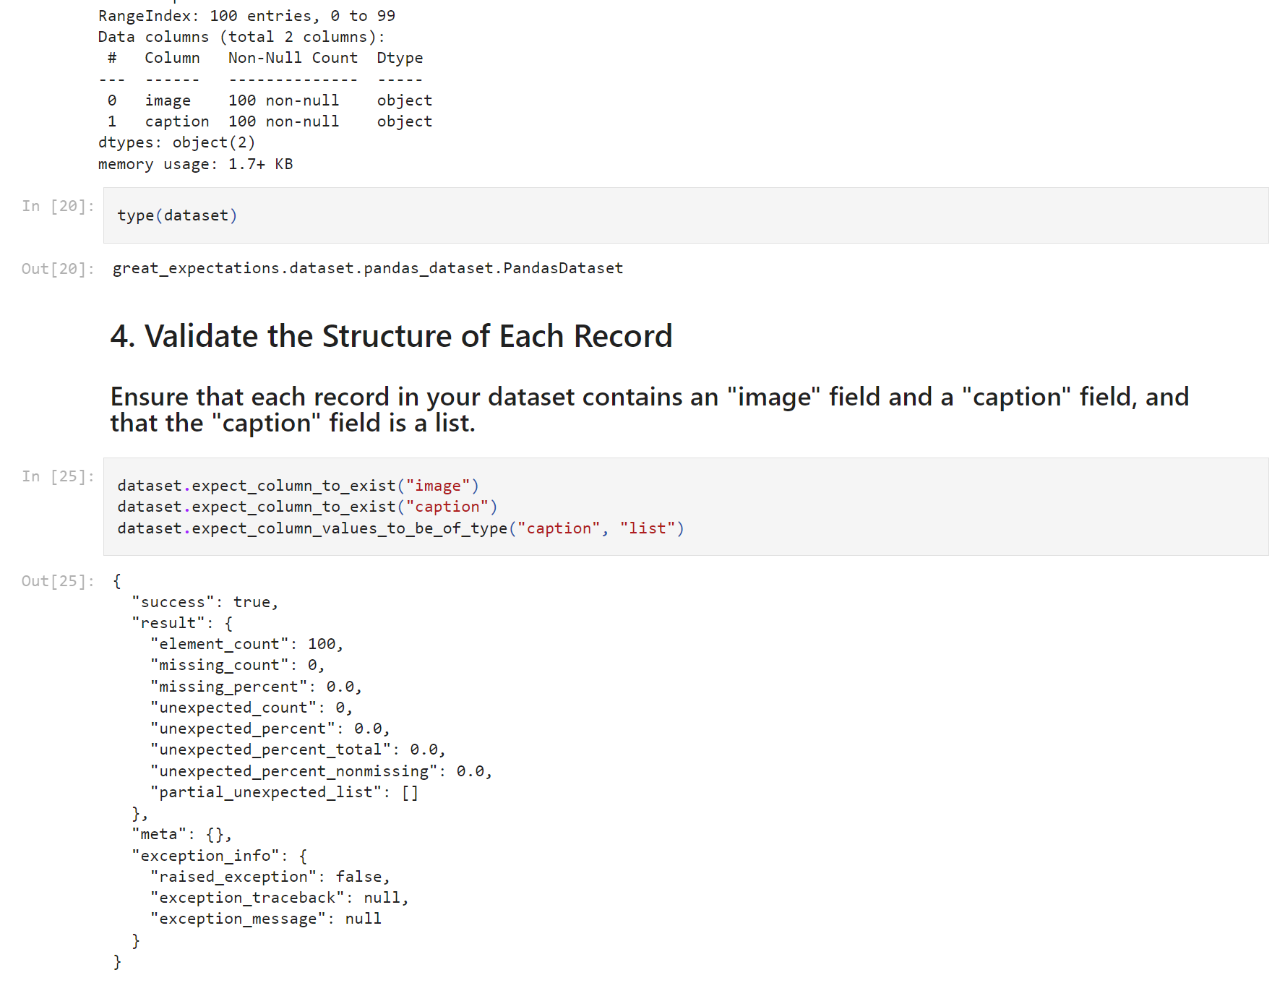

* + Feature Engineering store

Preprocessing and feature engineering are critical for effective machine learning model performance. The preprocessing steps transform raw data into structured formats optimized for ingestion into Apache Cassandra, which is used as our feature store due to its scalability, fault tolerance, and high availability. This structured data is then meticulously engineered to extract meaningful features that enhance the model's ability to learn and make accurate predictions. By integrating Apache Cassandra into our ML pipeline, we ensure seamless access to up-to-date feature data for continuous training and inference, thereby enhancing the overall efficiency and effectiveness of our AI models in the Audieyes project. The process includes validating data using Great Expectations and leveraging various datasets and transformations for training and evaluation.

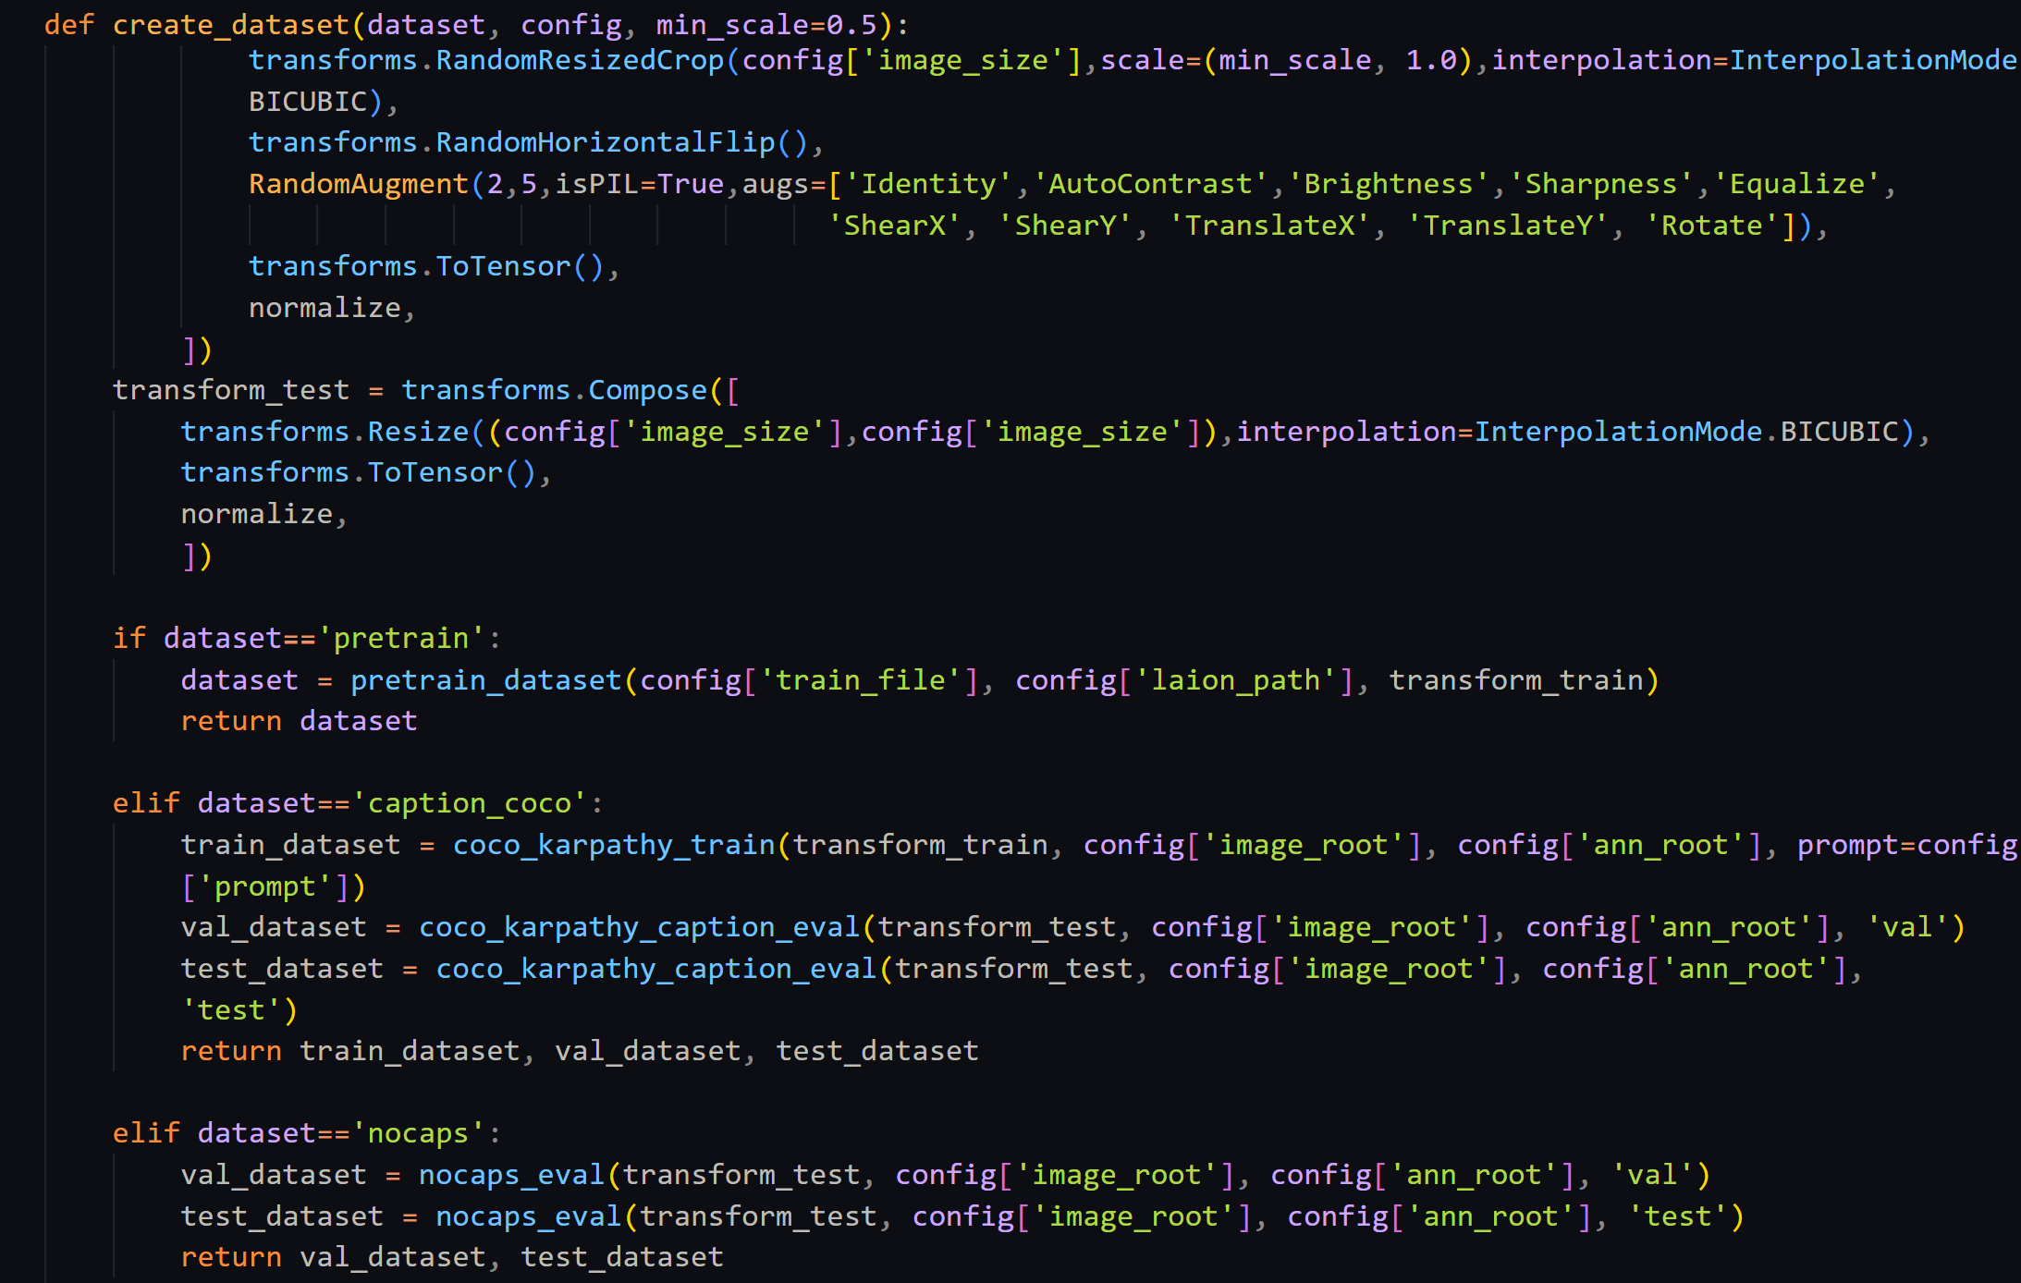

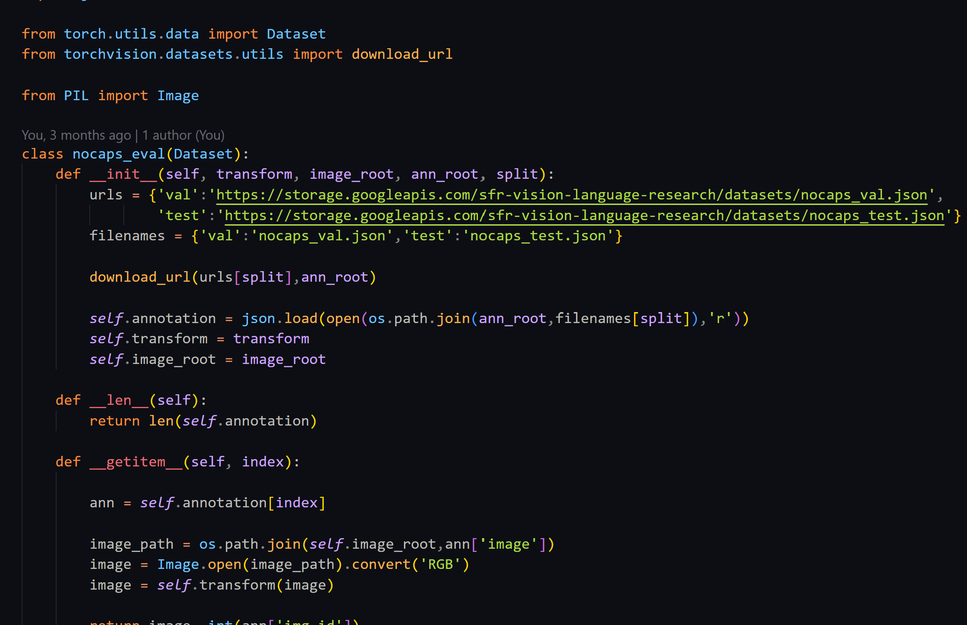

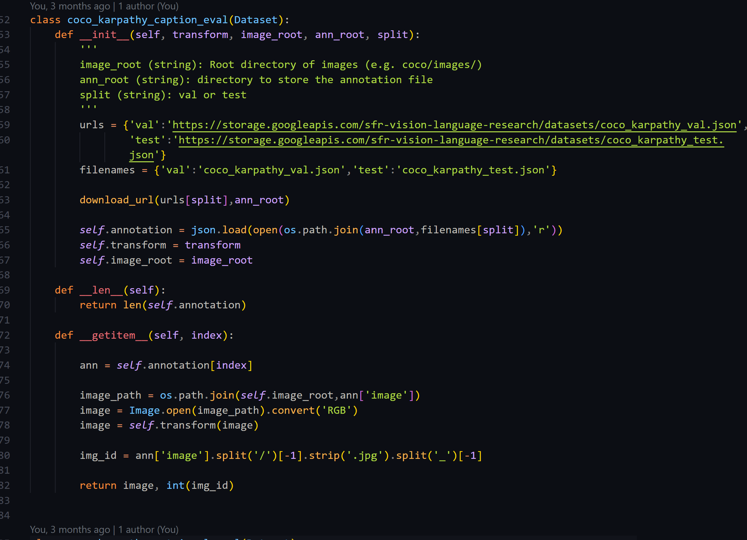

* + 1. Integration of model training and offline evaluation into the ML pipeline / MLOps Platform

I have used Automated tests in the pipeline to automatically run using github actions and cron jobs. View the file [here](https://github.com/AyoubMaimmadi/Audieyes/blob/main/.github/workflows/deployment.yaml).  
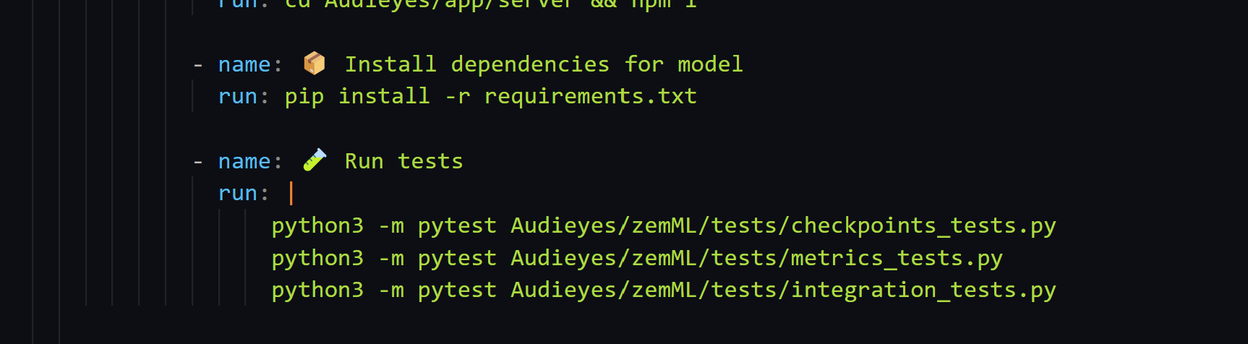

* + 1. **Development of model behavioral tests**

I have used GitHub Actions for running behavioural model tests. These tests validate the functionality and performance of the image captioning model, ensuring that it meets the specified requirements and quality standards. The tests are executed automatically whenever changes are made to the model codebase, providing continuous feedback on the model's behavior and performance.

**1. Model checkpoints Test:** the test checks that the model checkpoints are generated correctly and contain the expected parameters and metadata.

**2. Business Metrics Test:** the test evaluates the model's performance against predefined business metrics, such as operational efficiency, revenue and more.

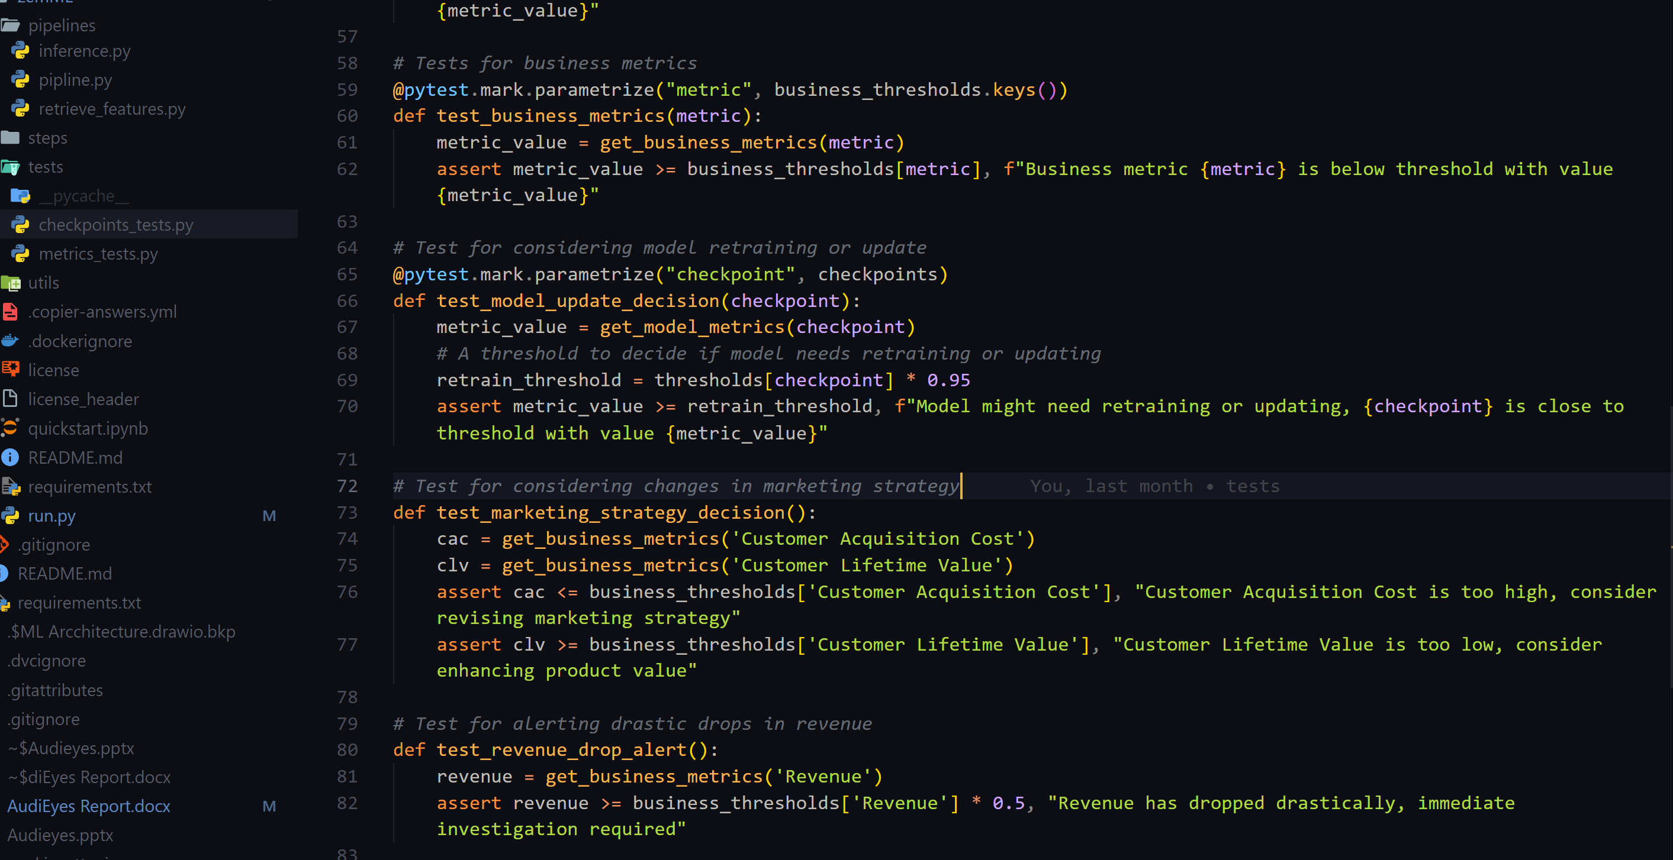

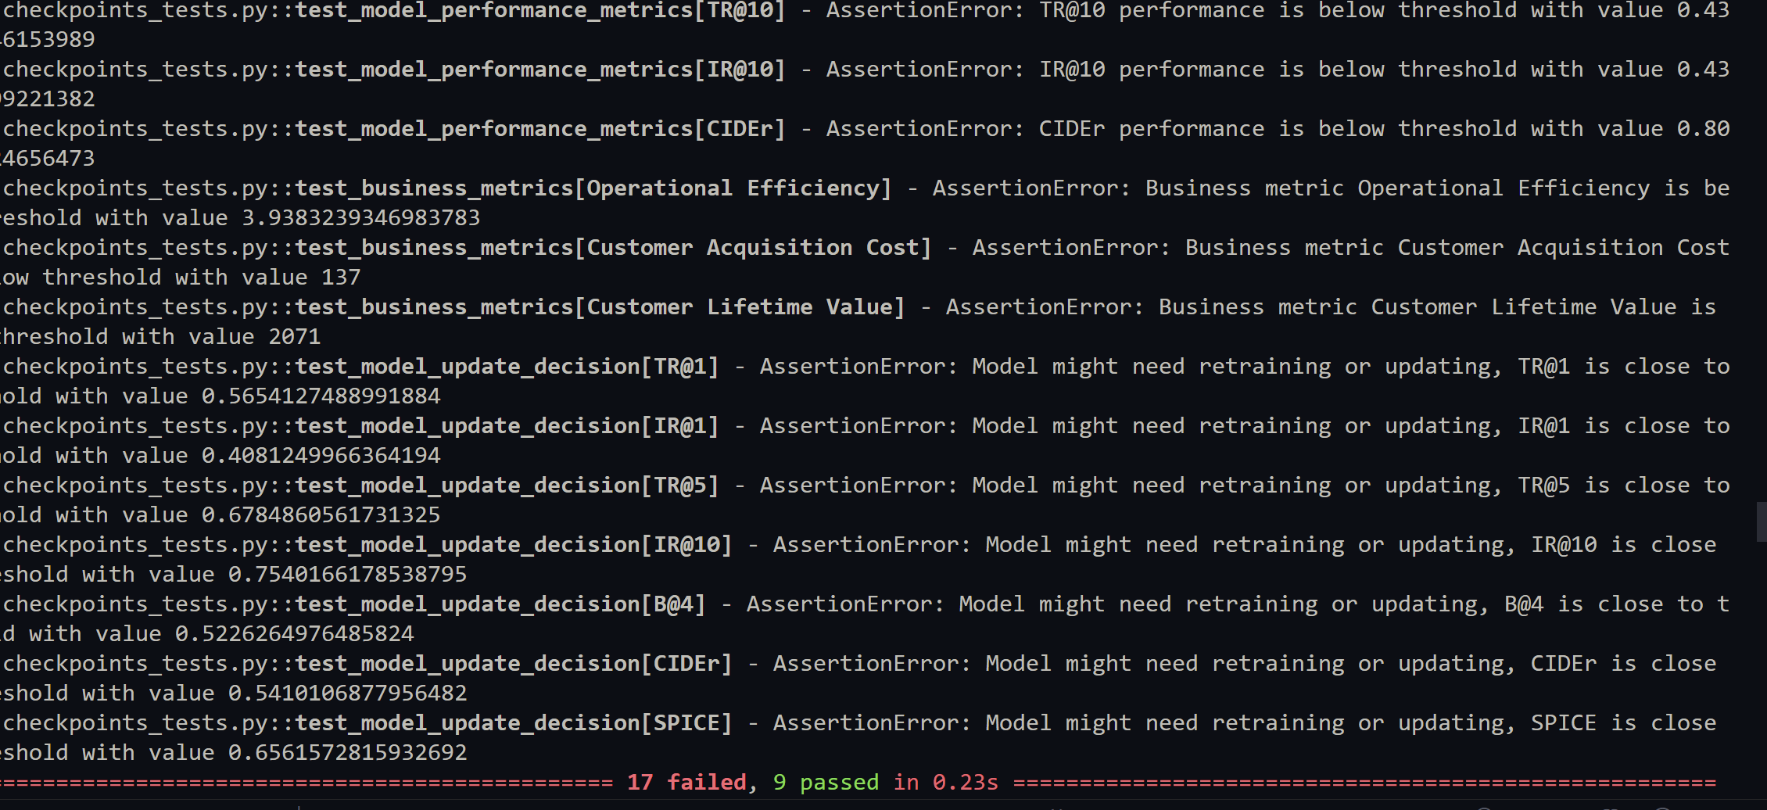

View details [here](https://github.com/AyoubMaimmadi/Audieyes/tree/main?tab=readme-ov-file#2---behavioural-model-tests).

**3. Model Deployment**

For the deployment phase of the Audieyes project, i have strategically chosen Docker, Linode, and Kubernetes to ensure a robust and scalable deployment of our machine learning models. Docker containers are utilized to package the AI models along with their dependencies, ensuring consistency across different computing environments from development to production.

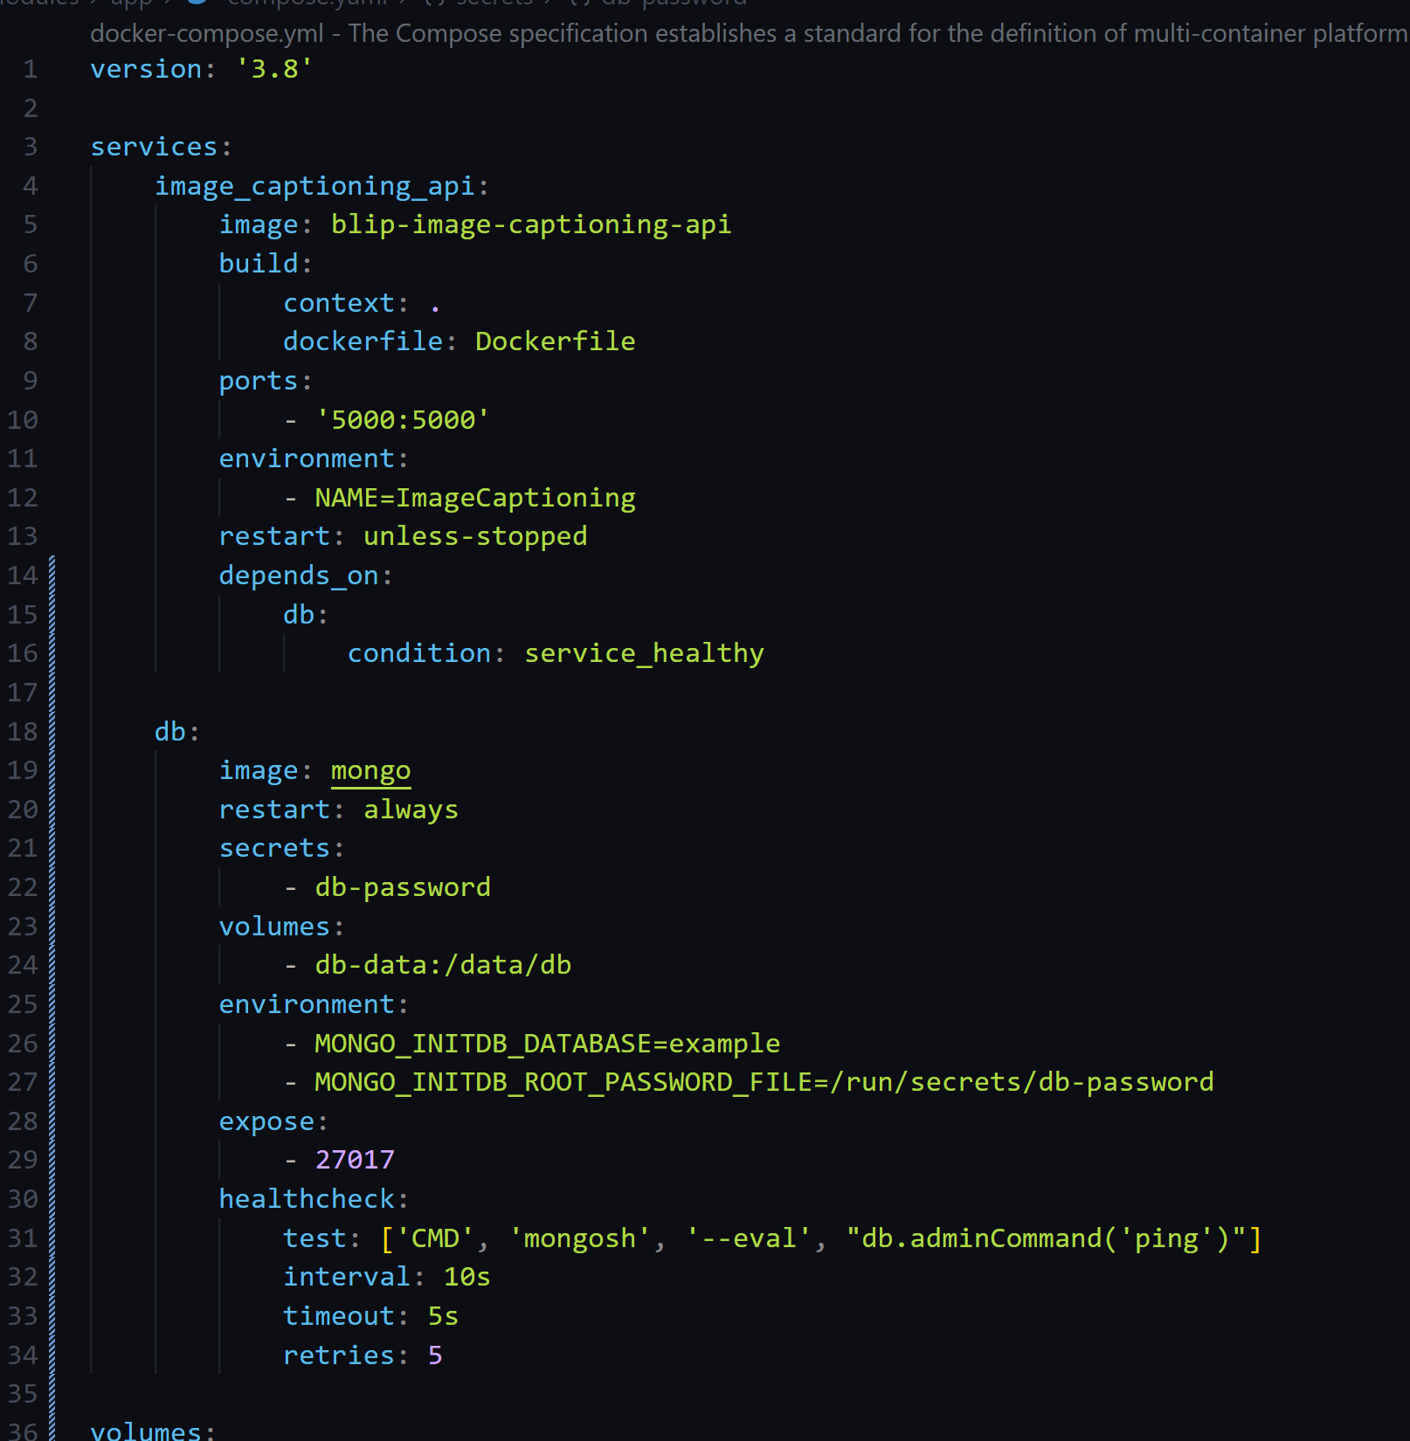

This containerization facilitates the easy management of model deployments and versioning, allowing for quick updates and rollbacks without disrupting the entire system.

I deploy these Docker containers using Kubernetes on Linode, a cloud hosting provider known for its simplicity and high performance. Linode enables us to scale our resources according to demand efficiently and ensures our application remains available with minimal downtime. This flexibility is particularly beneficial for handling the varying loads our service may experience as user numbers grow.

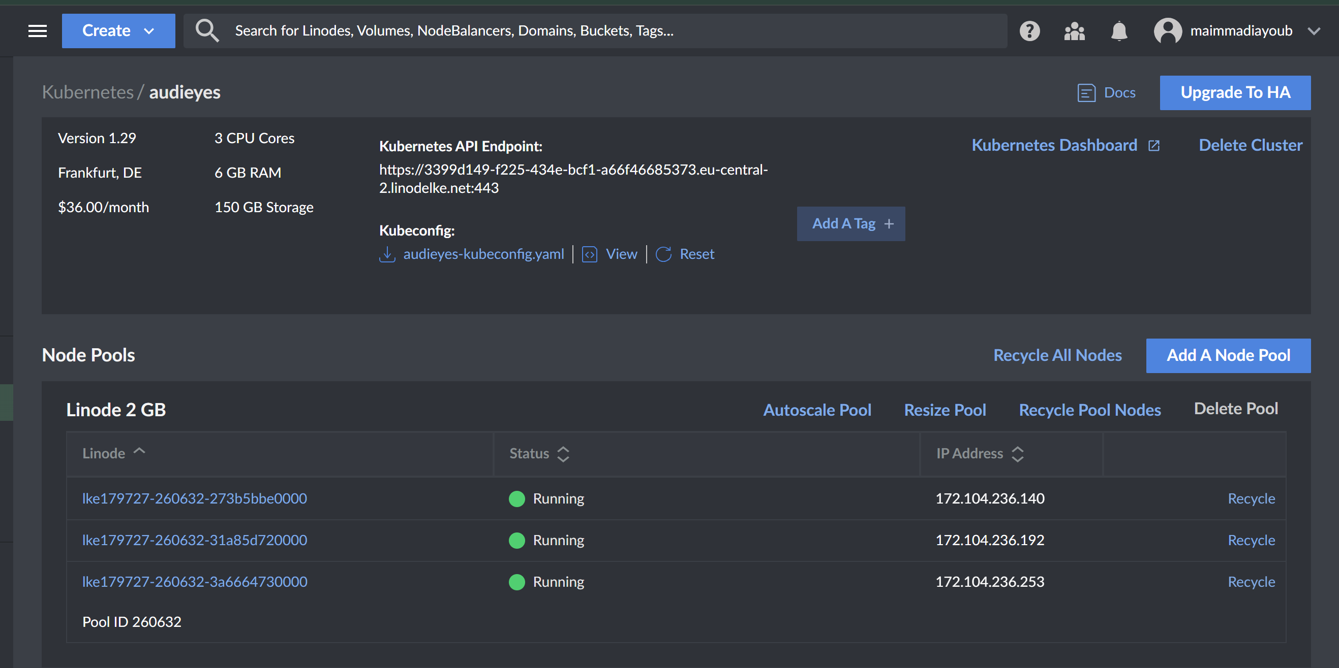

Kubernetes plays a crucial role in orchestrating these containers. It manages the deployment and scaling of our application, ensuring that I can seamlessly shift traffic between different model versions based on their performance. This orchestration is vital for maintaining high availability and performance, as Kubernetes can dynamically manage the application's load and distribute resources optimally across the containers.

This is the deployment of Audieyes:

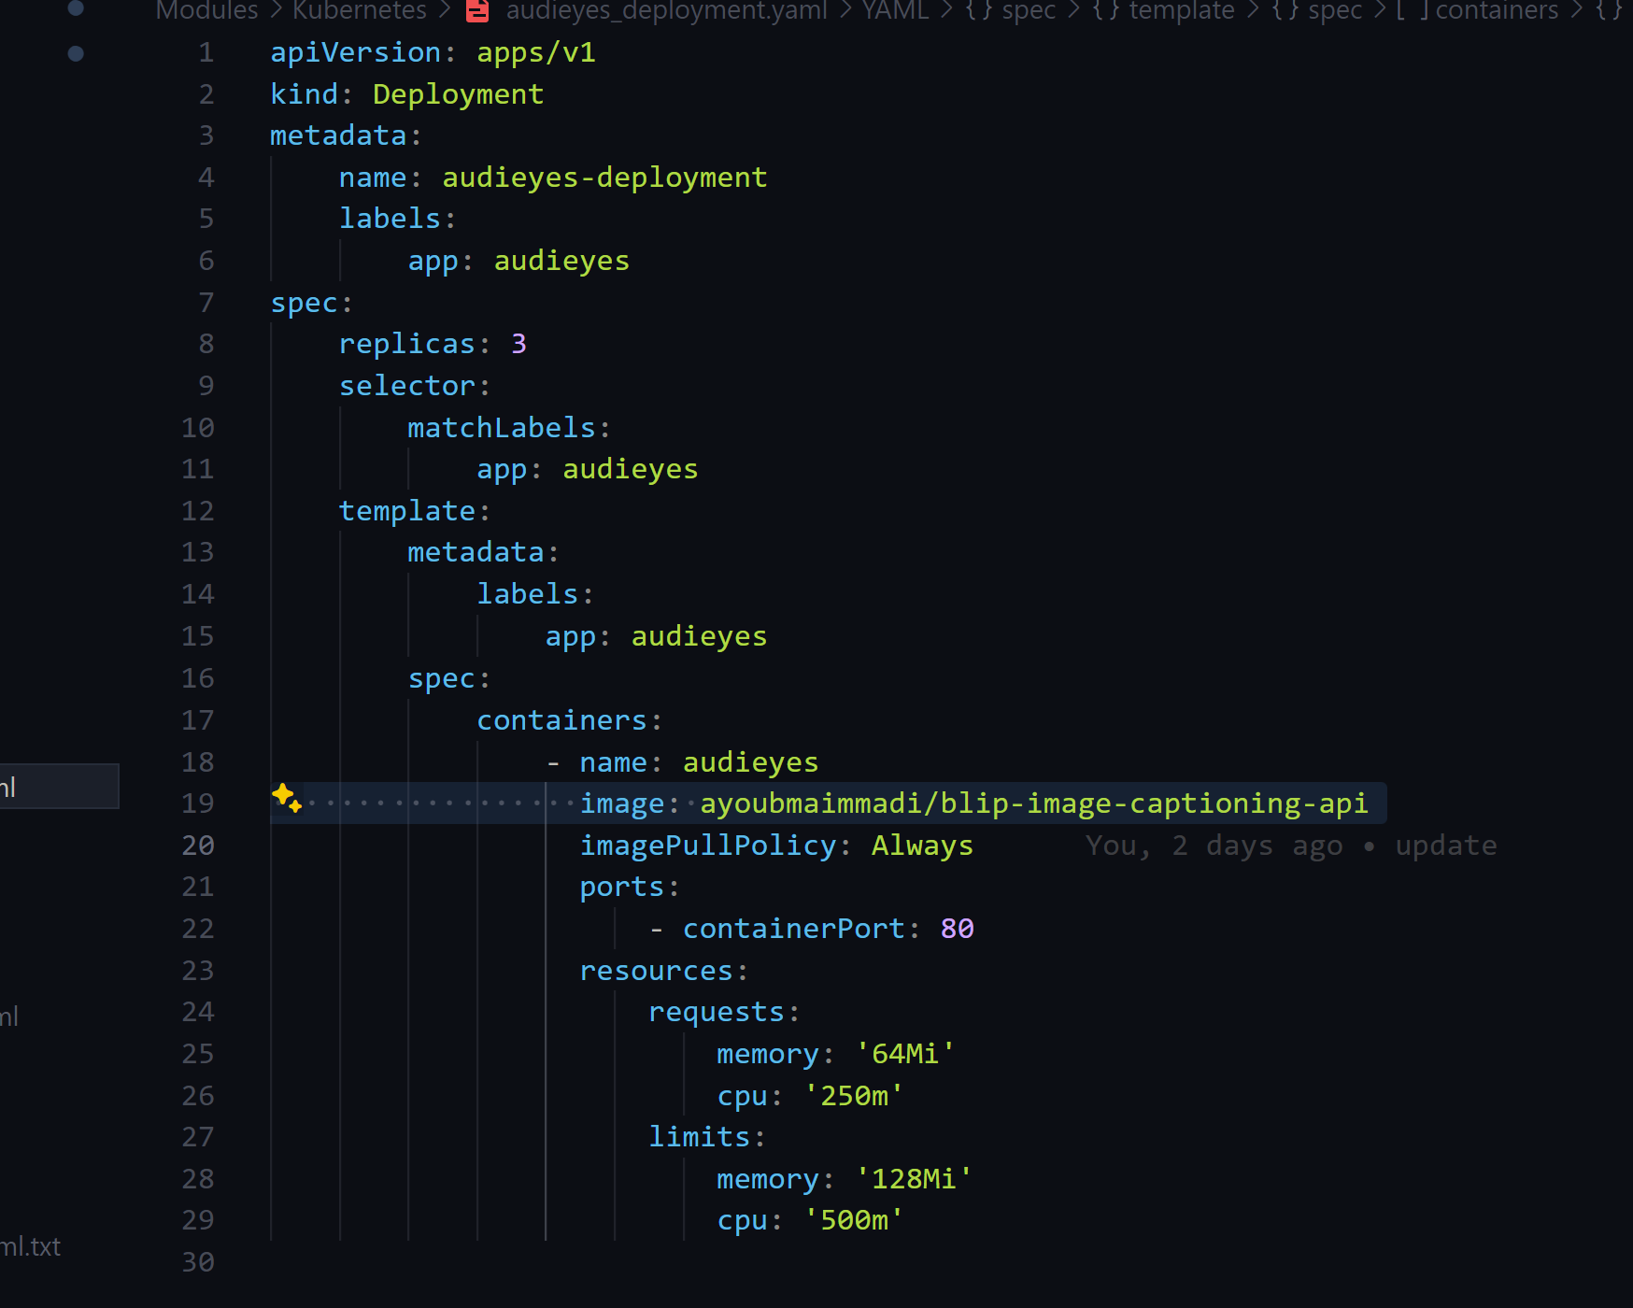

This is the service of Audieyes:  
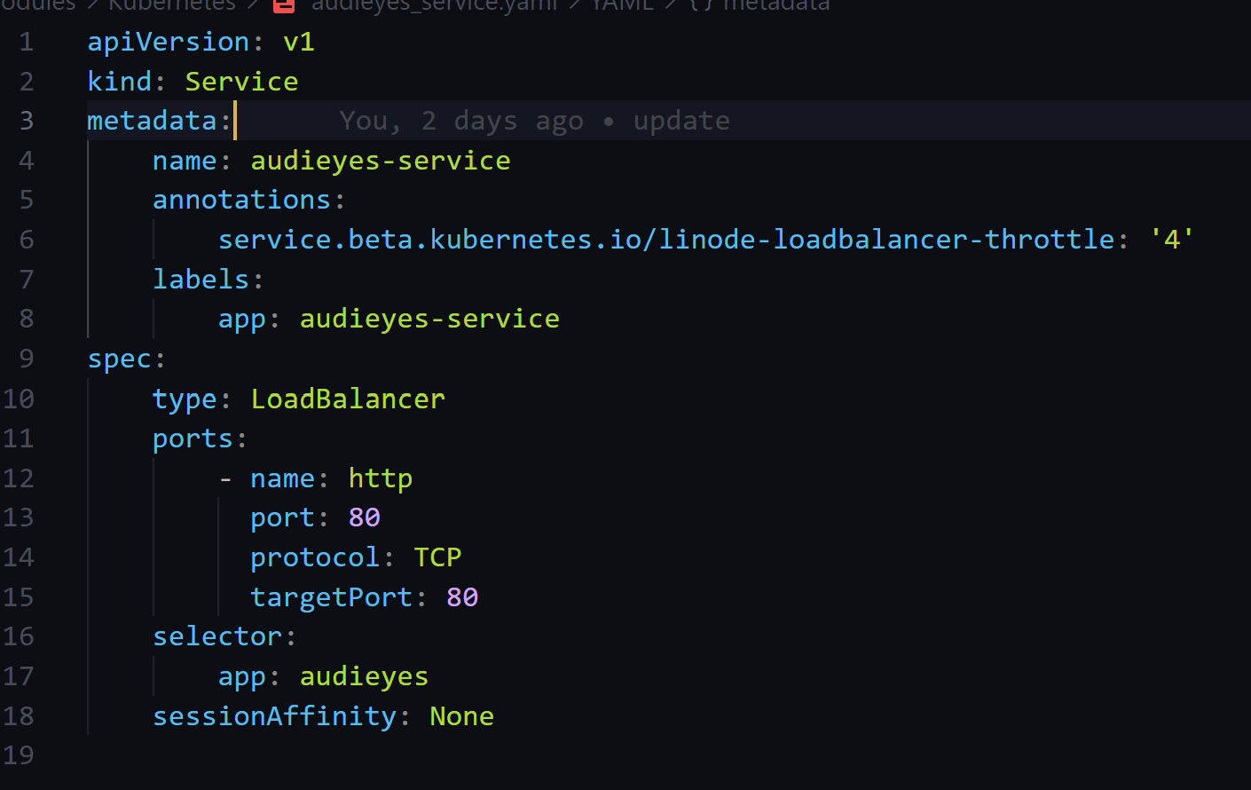

Together, Docker, Linode, and Kubernetes form a powerful trio that underpins our model deployment strategy, ensuring that Audieyes delivers a reliable, scalable, and efficient service to assist the visually impaired community.

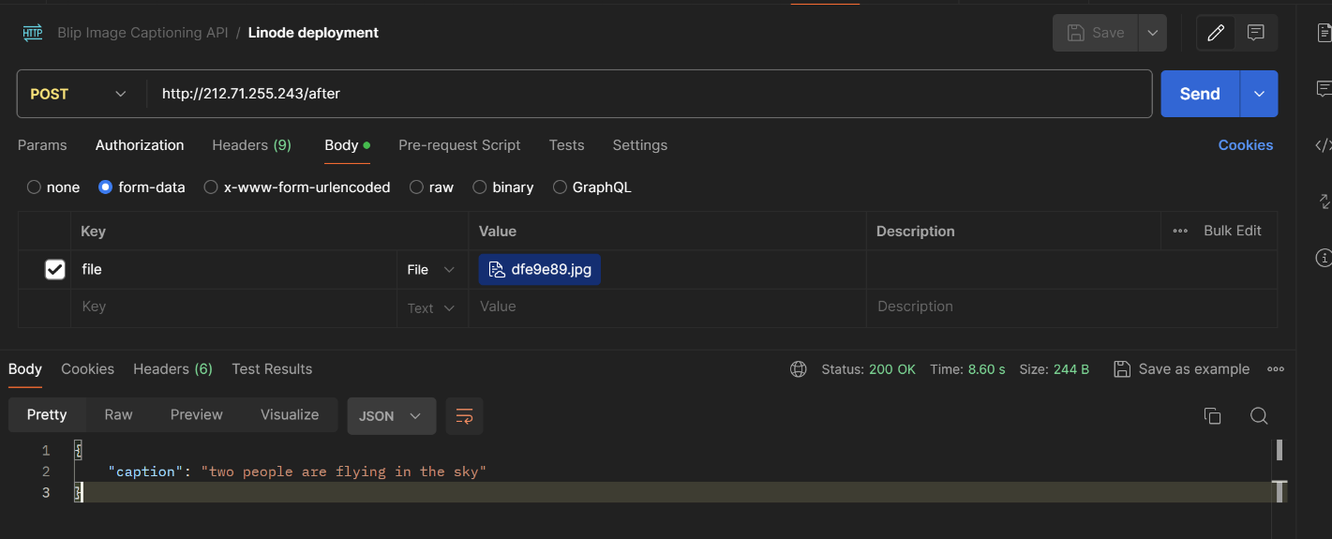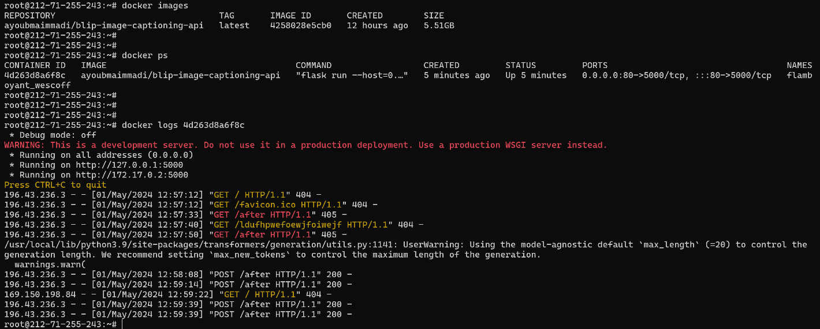

## 3.1 ML System Architecture

* Drawing with architecture highlights

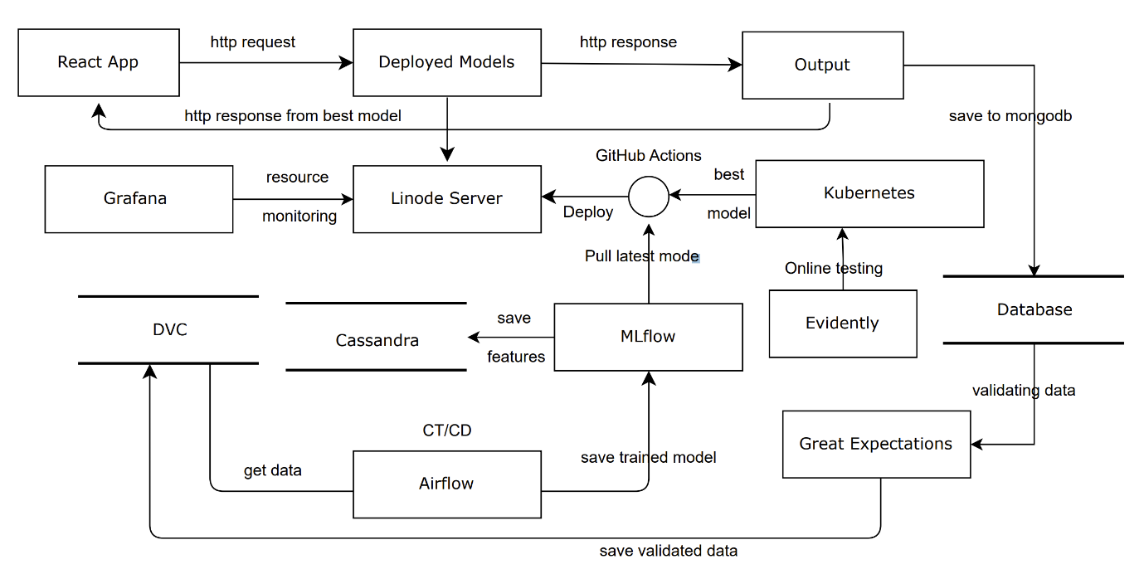

This architecture diagram outlines the workflow and interaction of various technologies in the deployment and operation of the Audieyes project. Here's a breakdown of each component and their interconnections:

1. React App: This is the front-end interface where users interact with the system. It sends HTTP requests to the deployed model and receives responses that are displayed to the user.
2. Deployed Model: This is the core AI model that processes incoming requests from the React app. It's responsible for executing the model's logic of image captioning.
3. Linode Server: Hosts the deployed model. It's the compute environment where the model runs and interacts with other components.
4. GitHub Actions: Used for continuous integration and deployment (CI/CD/CT). It automatically pulls the latest version of the model from the repository, builds it if necessary, and deploys it to the Linode server.
5. Kubernetes: Orchestration platform that manages the deployment of different model versions on the server. It ensures that the system scales efficiently and handles load balancing and auto-scaling.
6. Database: Stores and manages data, including user data, model inputs & outputs, and application logs. It's used by the system for persistent storage and retrieval of data needed for model validation and other processes.
7. Grafana: Monitors the model and system performance. It pulls metrics from the deployed model and other parts of the system to visualize performance and operational data.
8. Cassandra: Acts as the feature store. It stores and manages the features used by the machine learning models, enabling efficient feature retrieval for model training and inference.
9. MLflow: Manages the machine learning lifecycle, including experiment tracking, model versioning, and model storage. It saves trained models and interacts with other components to facilitate model deployment and monitoring.
10. Airflow: Automates and manages workflows, such as data preprocessing and feature engineering. It ensures that data is processed and made available to MLflow and Cassandra in the correct format.
11. Great Expectations: Validates and verifies data quality, ensuring that the data used throughout the system meets defined expectations before it's processed and used in model training.
12. DVC (Data Version Control): Manages and versions datasets, facilitating reproducibility of experiments and providing a mechanism to roll back to previous data versions if needed.

## 3.2 Application development

* Model service development

In the Audieyes project, the development of the model service is crucial for integrating and efficiently serving our machine learning models within the application's architecture. This involves encapsulating the models within a service layer, designed to facilitate seamless interactions between the React frontend and the complex machine learning operations. The service layer effectively manages requests from the frontend, processes these through the deployed models, and ensures timely and accurate responses.

To enhance scalability and reliability, I employ Kubernetes to orchestrate the deployment and operation of these model services. Kubernetes allows us to manage multiple instances of the model service dynamically, handling load balancing and ensuring that the system scales effectively under different load conditions. Crucially, Kubernetes also plays a pivotal role in model performance management by monitoring various model versions in production and seamlessly routing traffic to the best-performing models based on predefined metrics. This capability not only improves the overall system performance but also enhances user satisfaction by providing the most accurate and efficient responses.

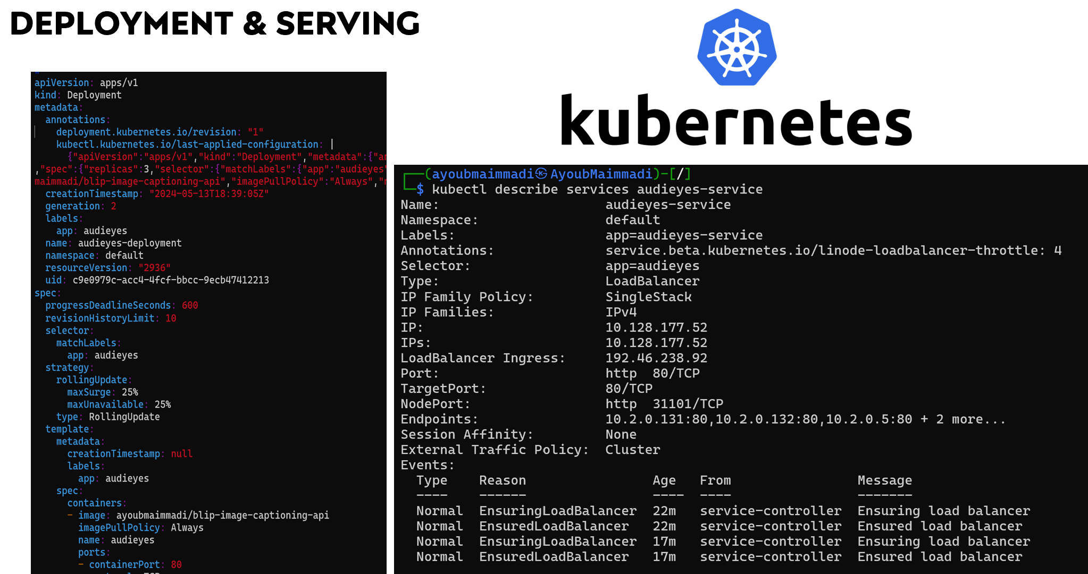

* Front-end client development

The development of the front-end client is centered around React, a popular JavaScript library known for its efficiency and flexibility in building interactive user interfaces. i chose React because it enables the creation of a responsive and dynamic experience for users, essential for our application which requires real-time updates and interactive features. The React app is designed to be user-friendly, providing visually impaired users with an intuitive interface that allows easy interaction with the image and video captioning features. This front-end client communicates seamlessly with the back-end services through RESTful APIs, fetching data and displaying results efficiently. The use of React also facilitates the rapid development of new features and easy maintenance of the codebase, thanks to its component-based architecture and the wide ecosystem of development tools and libraries available. View Details [here](https://github.com/AyoubMaimmadi/Audieyes/blob/main/Modules/app/react_app/README.md), and here a snippet of the front end code for the result page:

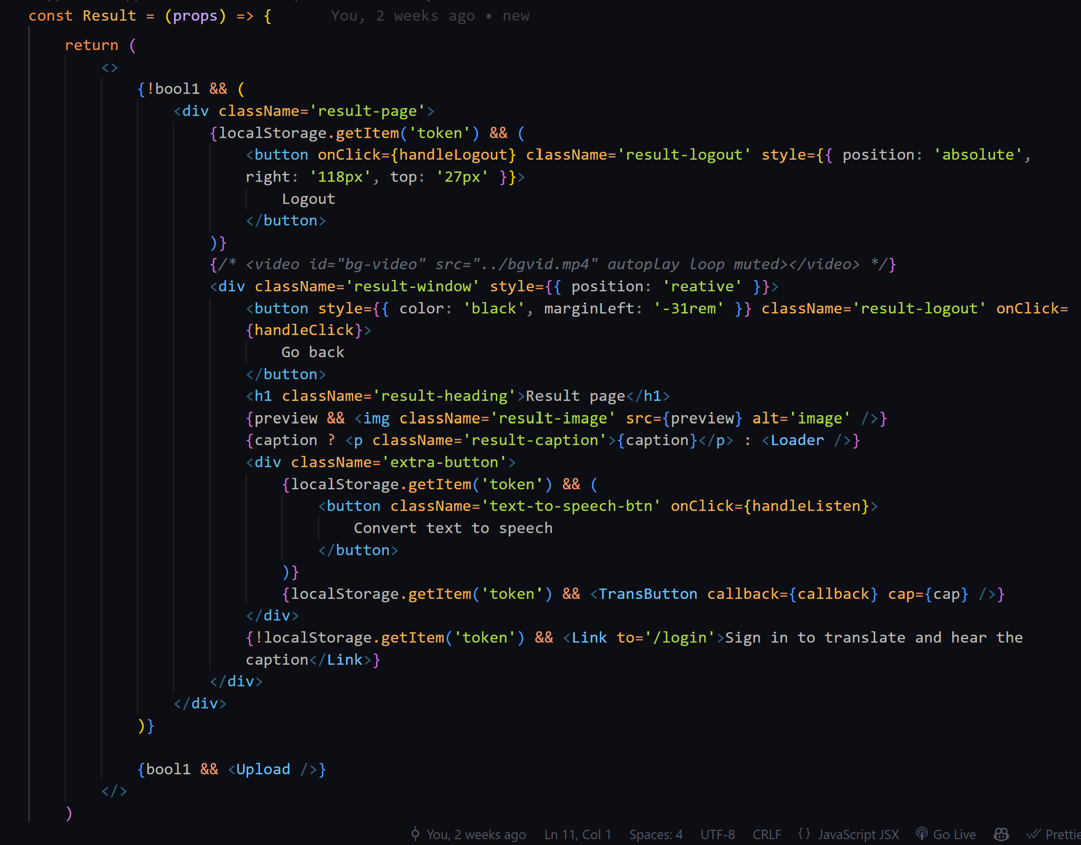

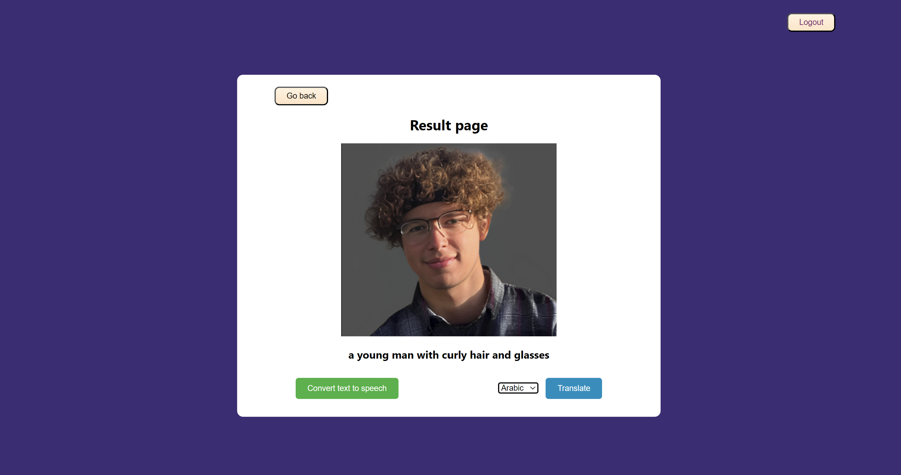

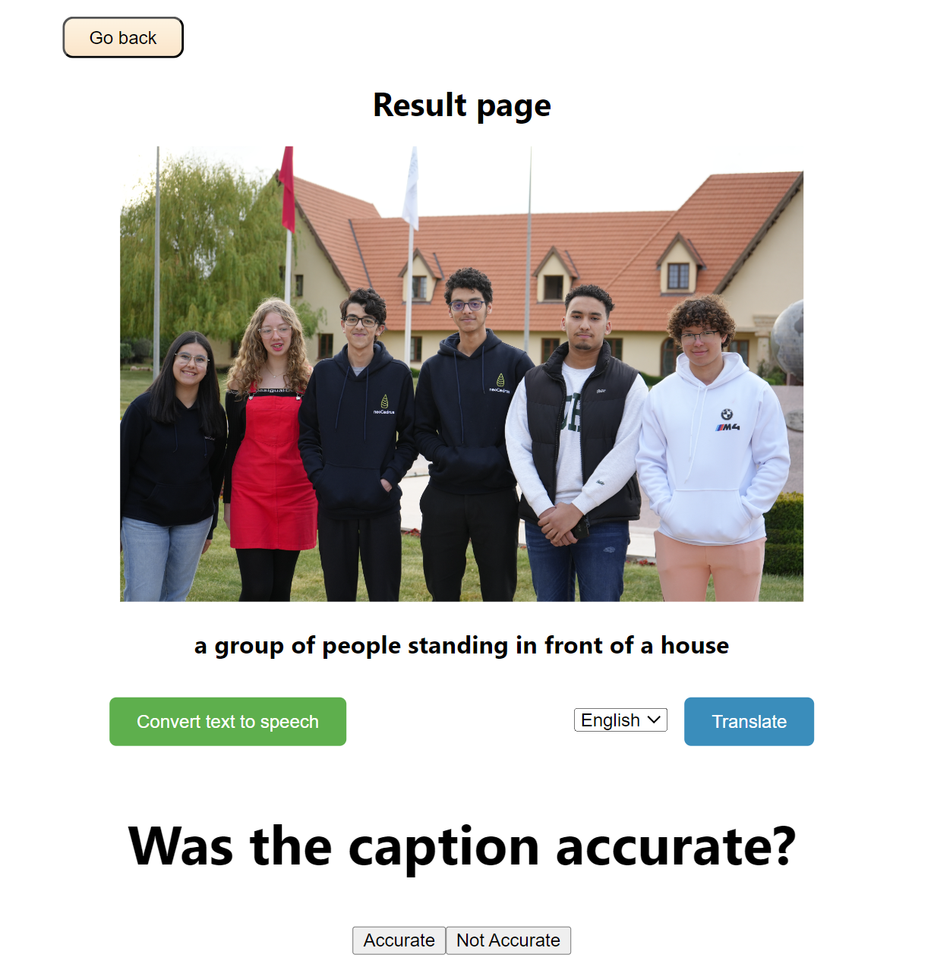

## 3.3 Integration and Deployment

* Packaging and containerization

The integration and deployment are streamlined through the use of packaging and containerization. i utilize Docker, a leading containerization technology, to package our application and its dependencies into lightweight, portable containers. This approach ensures consistency across development, testing, and production environments, eliminating the "it works on my machine" problem. Docker containers can be easily deployed on any system that supports Docker, regardless of the underlying infrastructure, which simplifies deployment and scaling operations. This method not only enhances the reproducibility of our application but also aligns with modern DevOps practices, allowing for rapid, reliable, and continuous deployment cycles facilitated by Kubernetes, which orchestrates container deployment, scaling, and management. View details [here](https://github.com/AyoubMaimmadi/Audieyes/blob/main/Modules/docker/README.md).

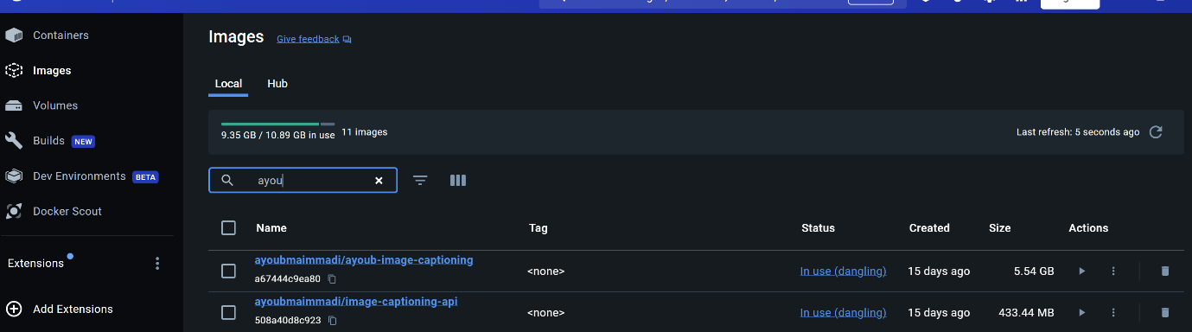

* Integration with a CI/CD Pipeline

For the Audieyes project, integration with a CI/CD pipeline is implemented using GitHub Actions to automate the build, test, and deployment processes. This setup ensures that every pull request or push triggers a series of actions that maintain the code quality and deployment readiness of our application. The CI/CD pipeline is composed of multiple jobs, starting with linting and testing where the code is checked for style and functionality issues. Node.js and Python environments are set up for respective dependencies and testing routines.

Post-validation, the train_evaluate_deploy job kicks in, which is contingent upon successful linting and testing. This job handles the model training, evaluation, Docker image creation, and pushing the image to a Docker registry. Finally, the trained model is deployed to a Linode server using SSH, where it's pulled and run inside a Docker container to ensure consistent execution environments. This CI/CD pipeline not only automates the workflow but also ensures that each component of our application is tested and deployed systematically, reducing human error and speeding up production cycles. This is triggered every month using Cron jobs. View details [here](https://github.com/AyoubMaimmadi/Audieyes/blob/main/.github/workflows/deployment.yaml).

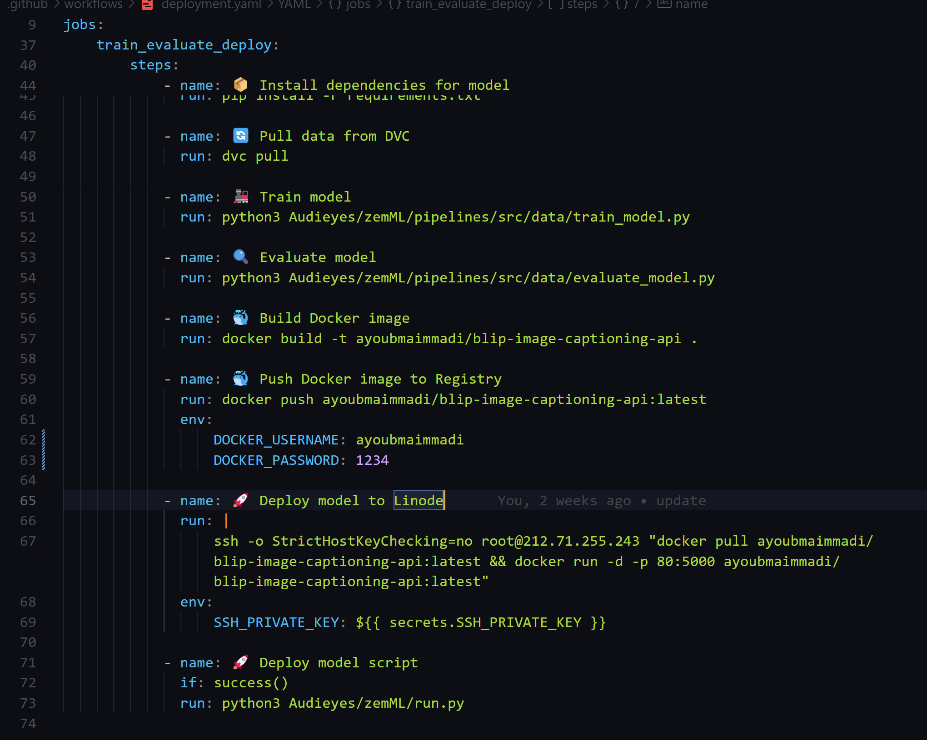

* Hosting the application

For hosting the Audieyes application, I utilize Linode, a cloud hosting service known for its reliability and scalability. Linode provides a robust infrastructure that allows us to deploy our containerized application components, managed by Kubernetes, ensuring efficient load balancing, auto-scaling, and seamless deployment of updates. This setup guarantees high availability and performance, essential for delivering continuous service to our users. The choice of Linode as our hosting solution supports our needs for a flexible and cost-effective cloud environment, enabling us to maintain optimal service levels as user demand and system complexity grow. View details [here](https://github.com/AyoubMaimmadi/Audieyes?tab=readme-ov-file#3--ml-service-deployment-and-model-serving).

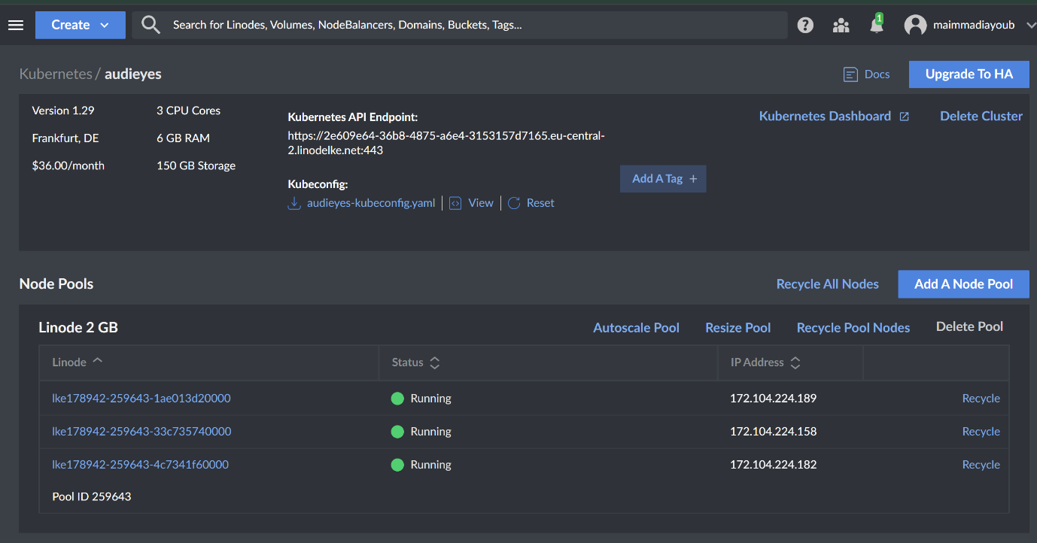

## 3.4. Model Serving and online testing

* Model serving runtime

Model serving and online testing are streamlined through a robust Kubernetes-based model serving runtime. This setup involves deploying our machine learning models within a Kubernetes cluster, which can handle requests in real time, ensuring that users receive immediate and accurate responses. The models are hosted on nodes configured with the necessary computational resources to perform at scale, and they are accessible through a well-defined API that allows the React front-end to interact seamlessly with the model serving backend. Kubernetes ensures high availability, scalability, and efficient load balancing for the model serving infrastructure.

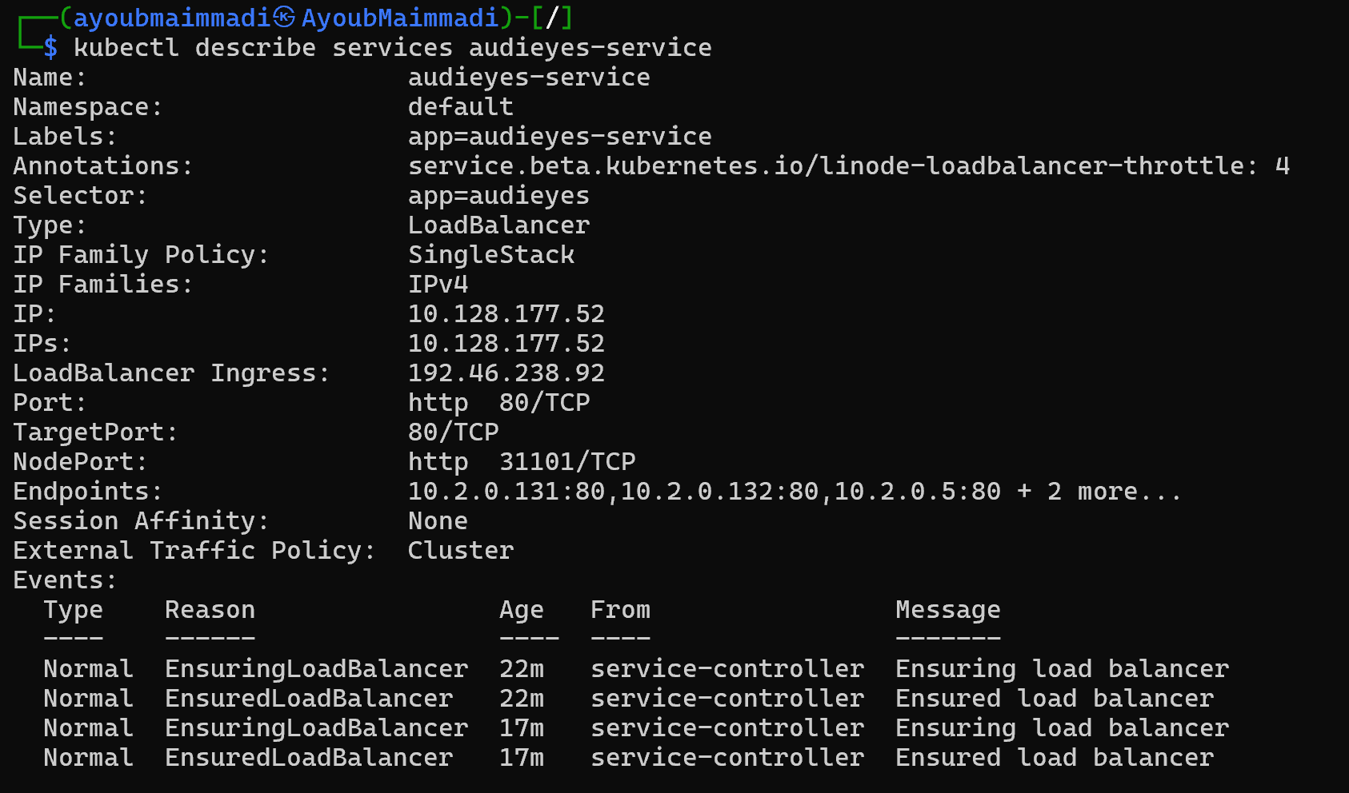

* Serving mode

The model serving approach is designed to cater to on-demand requests with a focus on delivering results directly to end-users. This serving mode ensures that users receive real-time, accurate information.

For the model serving runtime, I utilize a robust infrastructure that supports high availability and rapid response times. The deployment is managed through containerization with Docker, which allows the models to be served efficiently and scaled dynamically according to demand. This setup is orchestrated by Kubernetes, which manages the containers and ensures that the model serving runtime is always optimized for performance, handling load balancing and fault tolerance seamlessly. This combination provides a reliable and efficient environment for model serving, crucial for maintaining the responsiveness and accuracy required by the Audieyes application.

* Online testing

Online testing, including A/B testing and evaluation of model performance, is crucial in optimizing and ensuring the effectiveness of our machine learning models. In the Audieyes project, I implemented online testing using Evidently, a tool deployed within a Kubernetes environment to monitor and compare different model versions. The setup involves deploying the Evidently metrics fetcher as a Kubernetes service, allowing real-time monitoring of model performance. By using Evidently, we can dynamically evaluate the impact of different models based on user interactions and system performance metrics. Here is the Kubernetes configuration for the Evidently metrics fetcher:

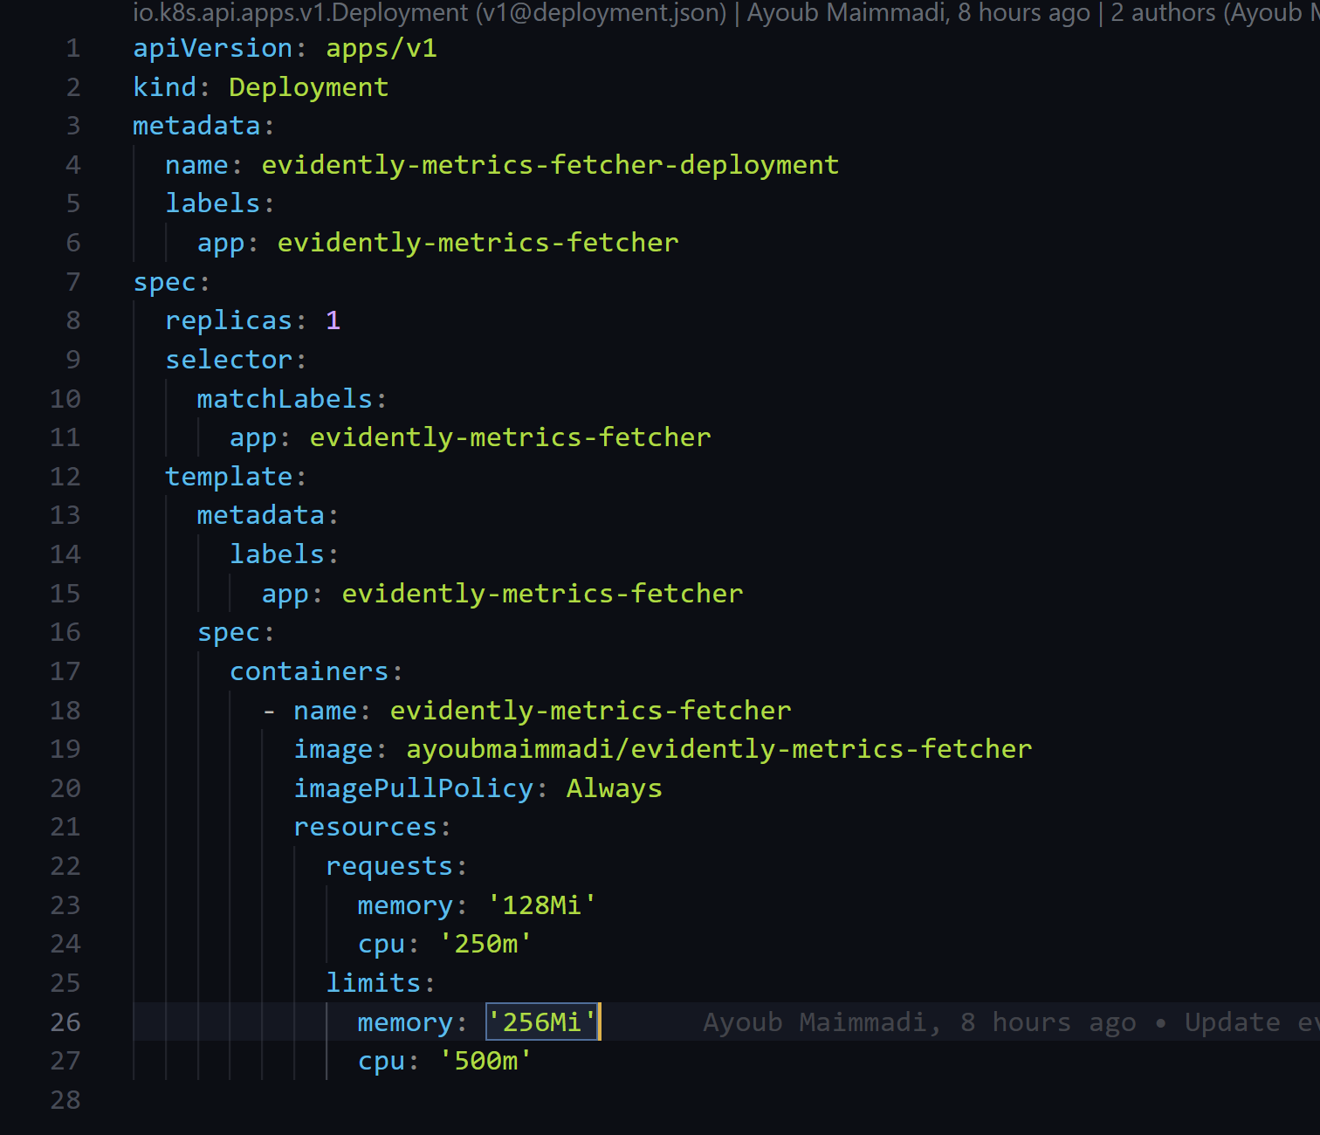

user feedback based on accuracy🡪 how its recorded:



Code to serve best model based on user feedback

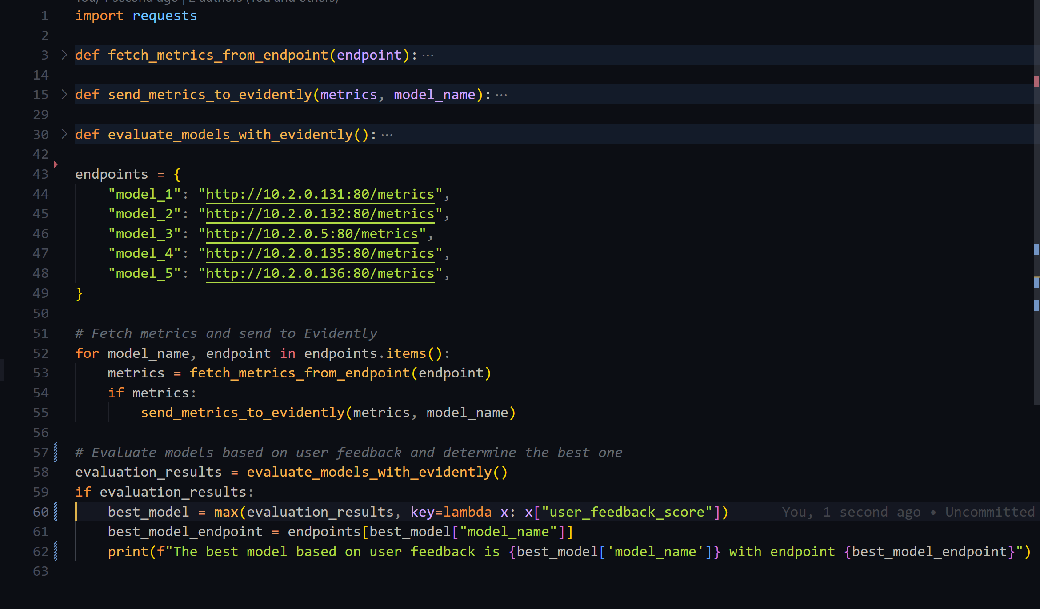

# Monitoring and Continual Learning

## 4.1. Resource Monitoring

In the Audieyes project, resource monitoring is a critical component to ensure that our machine learning models and services run efficiently and reliably. To achieve this, I utilize Linode's comprehensive statistics and monitoring tools. Linode provides detailed insights into various aspects of server performance, such as CPU usage, memory consumption, disk I/O, and network traffic.

By leveraging Linode's statistics, I can monitor the health and performance of the servers hosting our models in real-time. This allows for proactive management, enabling quick responses to any potential issues such as resource bottlenecks or unexpected spikes in usage. For instance, if the CPU usage consistently approaches maximum capacity, I can allocate additional resources or optimize the model to reduce computational demands. Linode's monitoring tools also offer alerting capabilities.

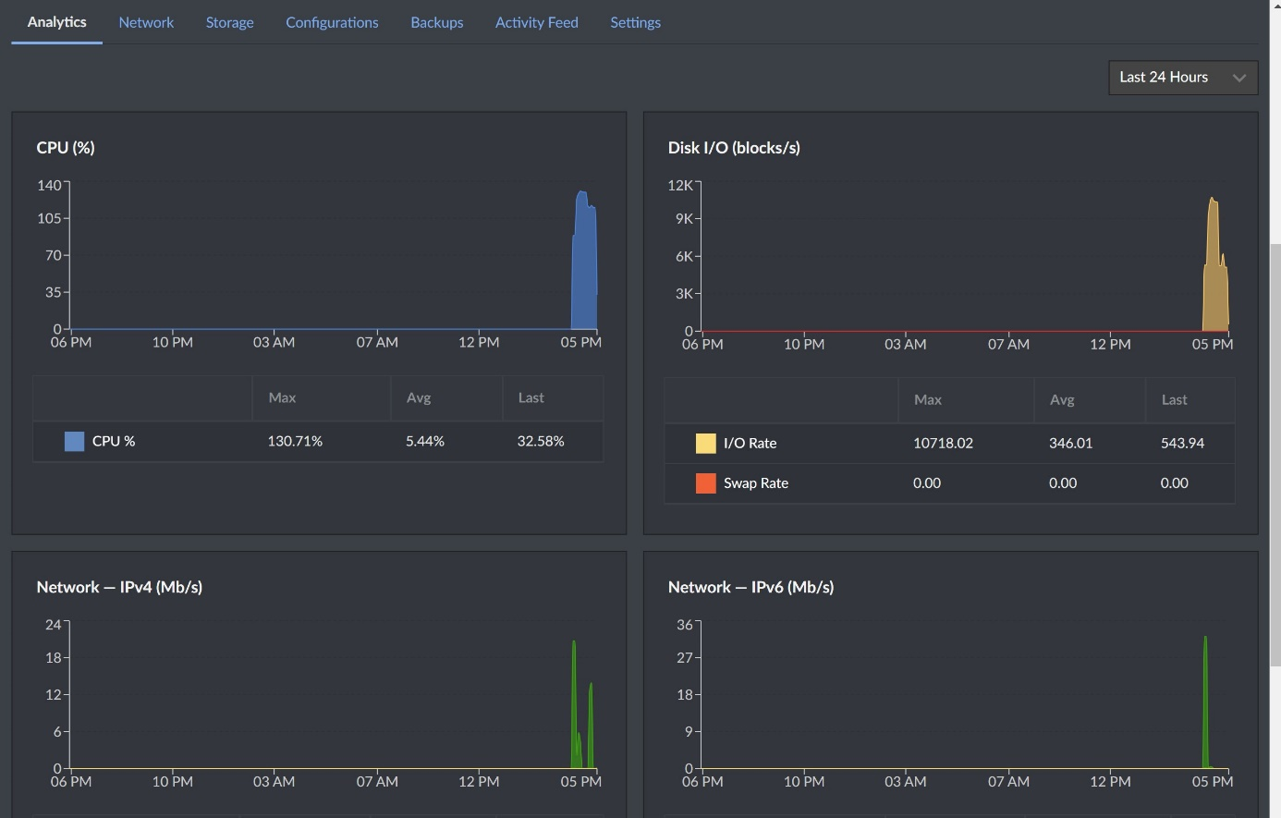

I have set up alerts to notify me when specific thresholds are exceeded, such as high memory usage or low disk space. These alerts help in maintaining the availability and performance of our services, ensuring that users always experience smooth and responsive interactions with the Audieyes application.

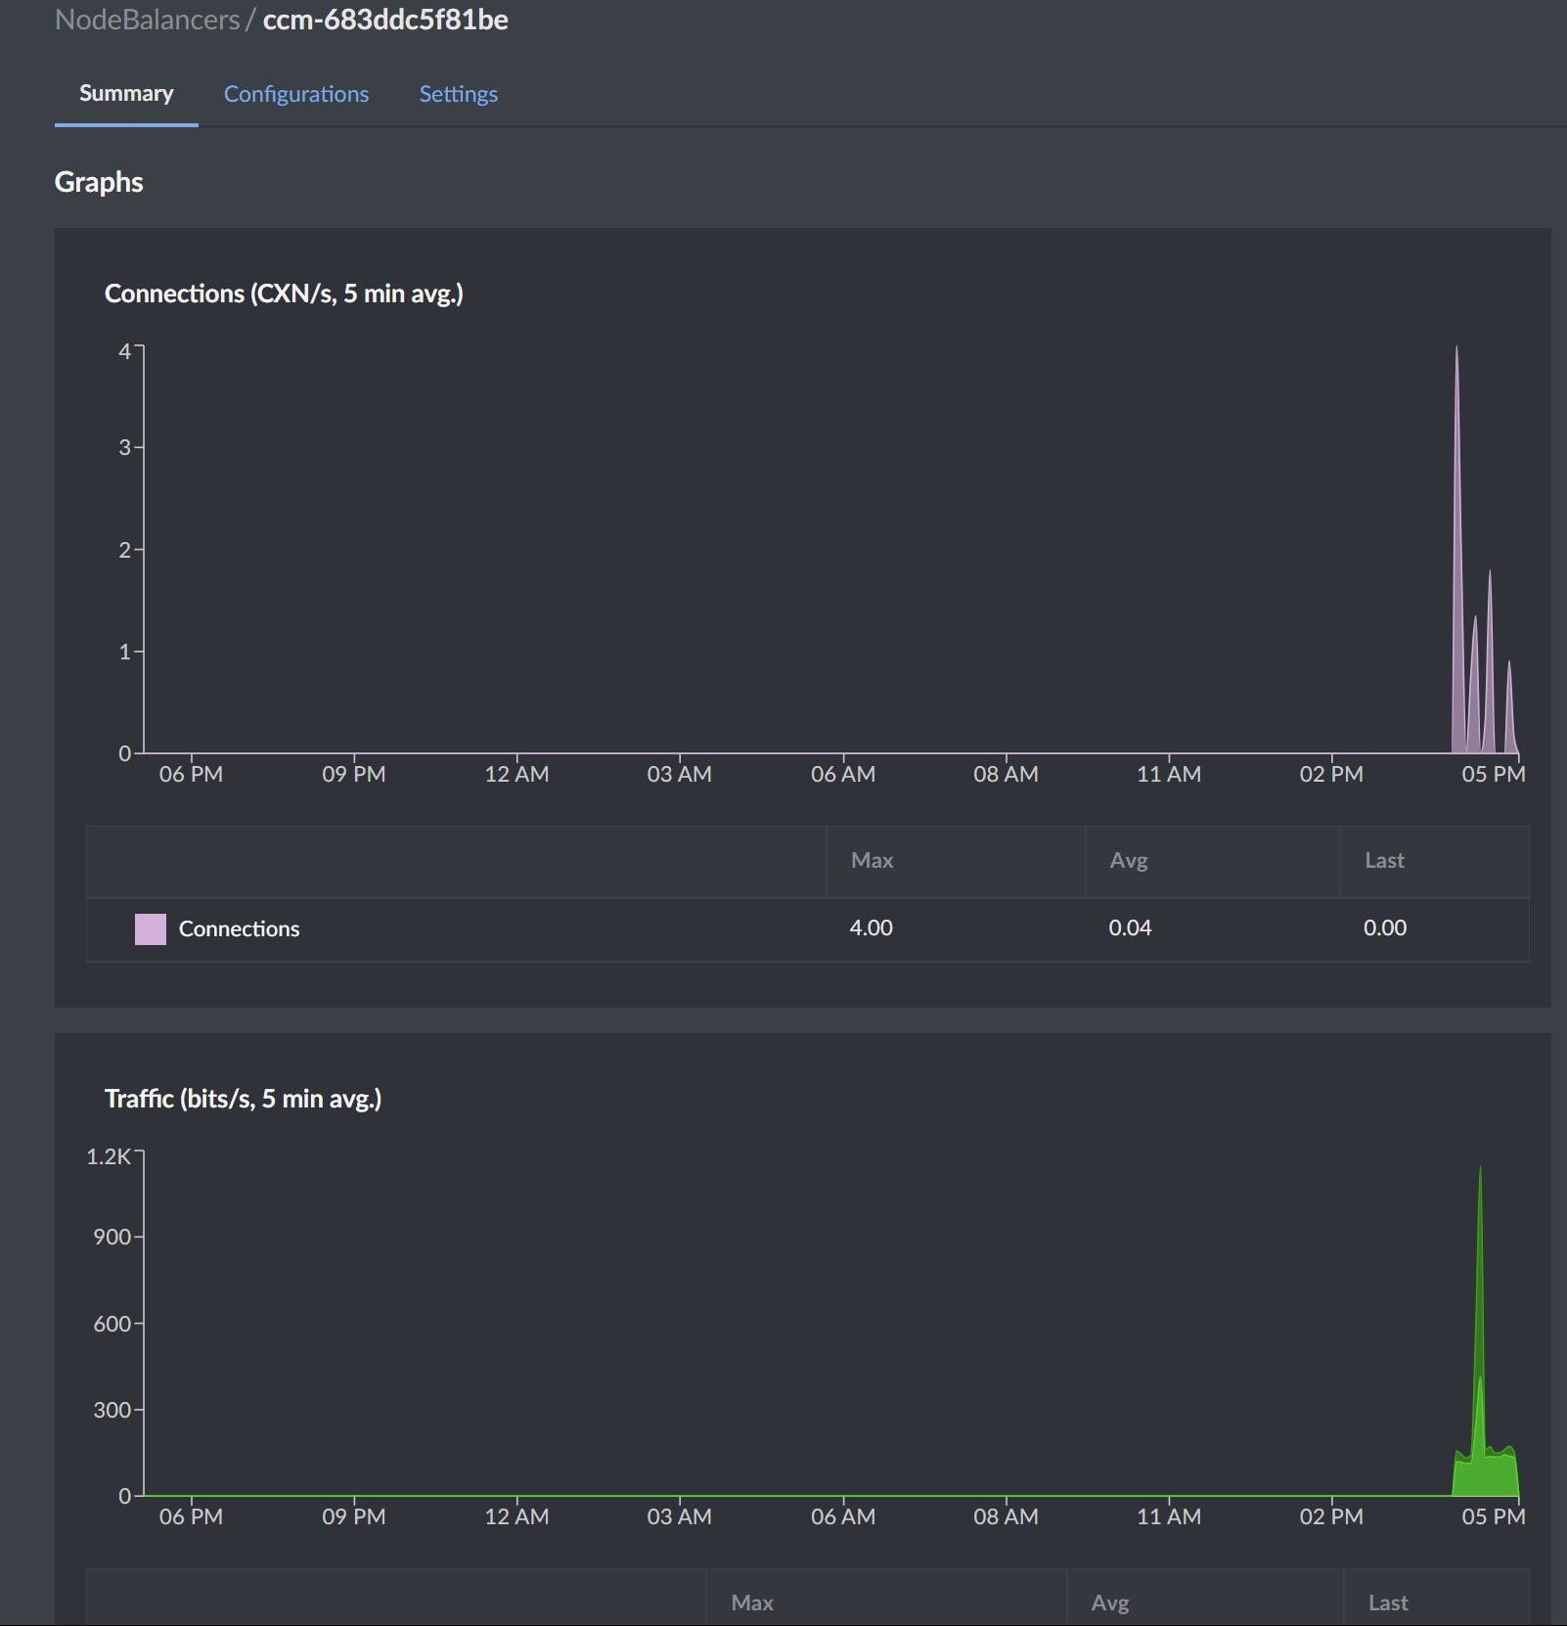

## 4.2. Model Performance Monitoring or data distribution drift Monitoring

## Monitoring model performance and detecting data distribution drift are vital for ensuring the long-term reliability and accuracy of our machine learning models. To achieve this, I have implemented a comprehensive monitoring system using tools like Grafana, Linode, and Evidently. Evidently is used specifically for monitoring the performance of our image captioning model. It provides comprehensive insights into the model's behavior, enabling users to track key metrics, detect anomalies, and identify areas for improvement. One critical aspect of this monitoring is the detection of data distribution drift. To catch data drifts, I provided Evidently with a dataset containing noise to simulate changes in the data distribution. By comparing the model's performance on this noisy dataset with its performance on the original dataset, Evidently can detect any significant drops in accuracy. If the accuracy drops, it indicates a data drift, prompting further investigation and model retraining if necessary. This proactive approach ensures that our models maintain high accuracy and reliability over time, adapting to changes in the input data distribution and continuously providing accurate predictions.

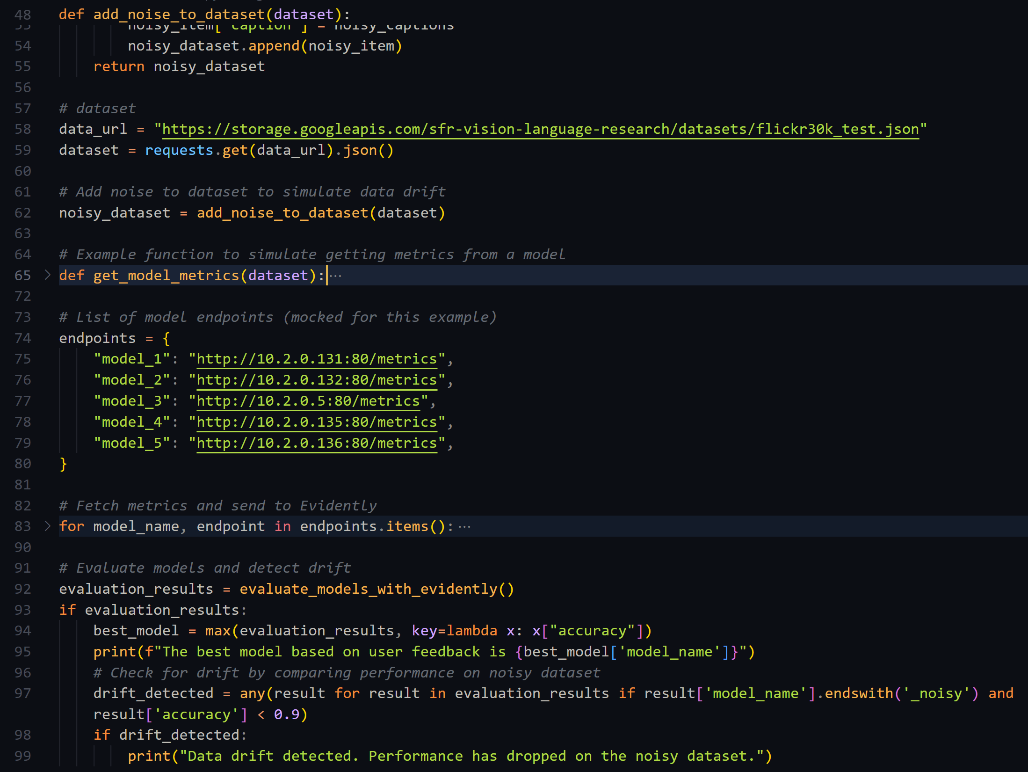

## 4.3. Continual Learning: CT/CD pipeline

We've implemented a Continual Learning (CL) pipeline integrated with Continuous Training (CT) and Continuous Deployment (CD) to ensure our models adapt to new data and evolving user needs effectively. This pipeline automates the process of retraining models on fresh data, evaluating their performance, and deploying improved versions without manual intervention. I utilize Apache Airflow to manage workflow automation, orchestrating tasks like data ingestion, preprocessing, model training, and validation. Once a new model version meets our performance criteria, it is automatically deployed to production using Kubernetes, which manages the rollout and ensures that there is no downtime or disruption to the service. This setup supports a dynamic learning environment where our models continually evolve and improve, maintaining high accuracy and relevance in real-world applications. View details [here](https://github.com/AyoubMaimmadi/Audieyes/blob/main/.github/workflows/deployment.yaml).

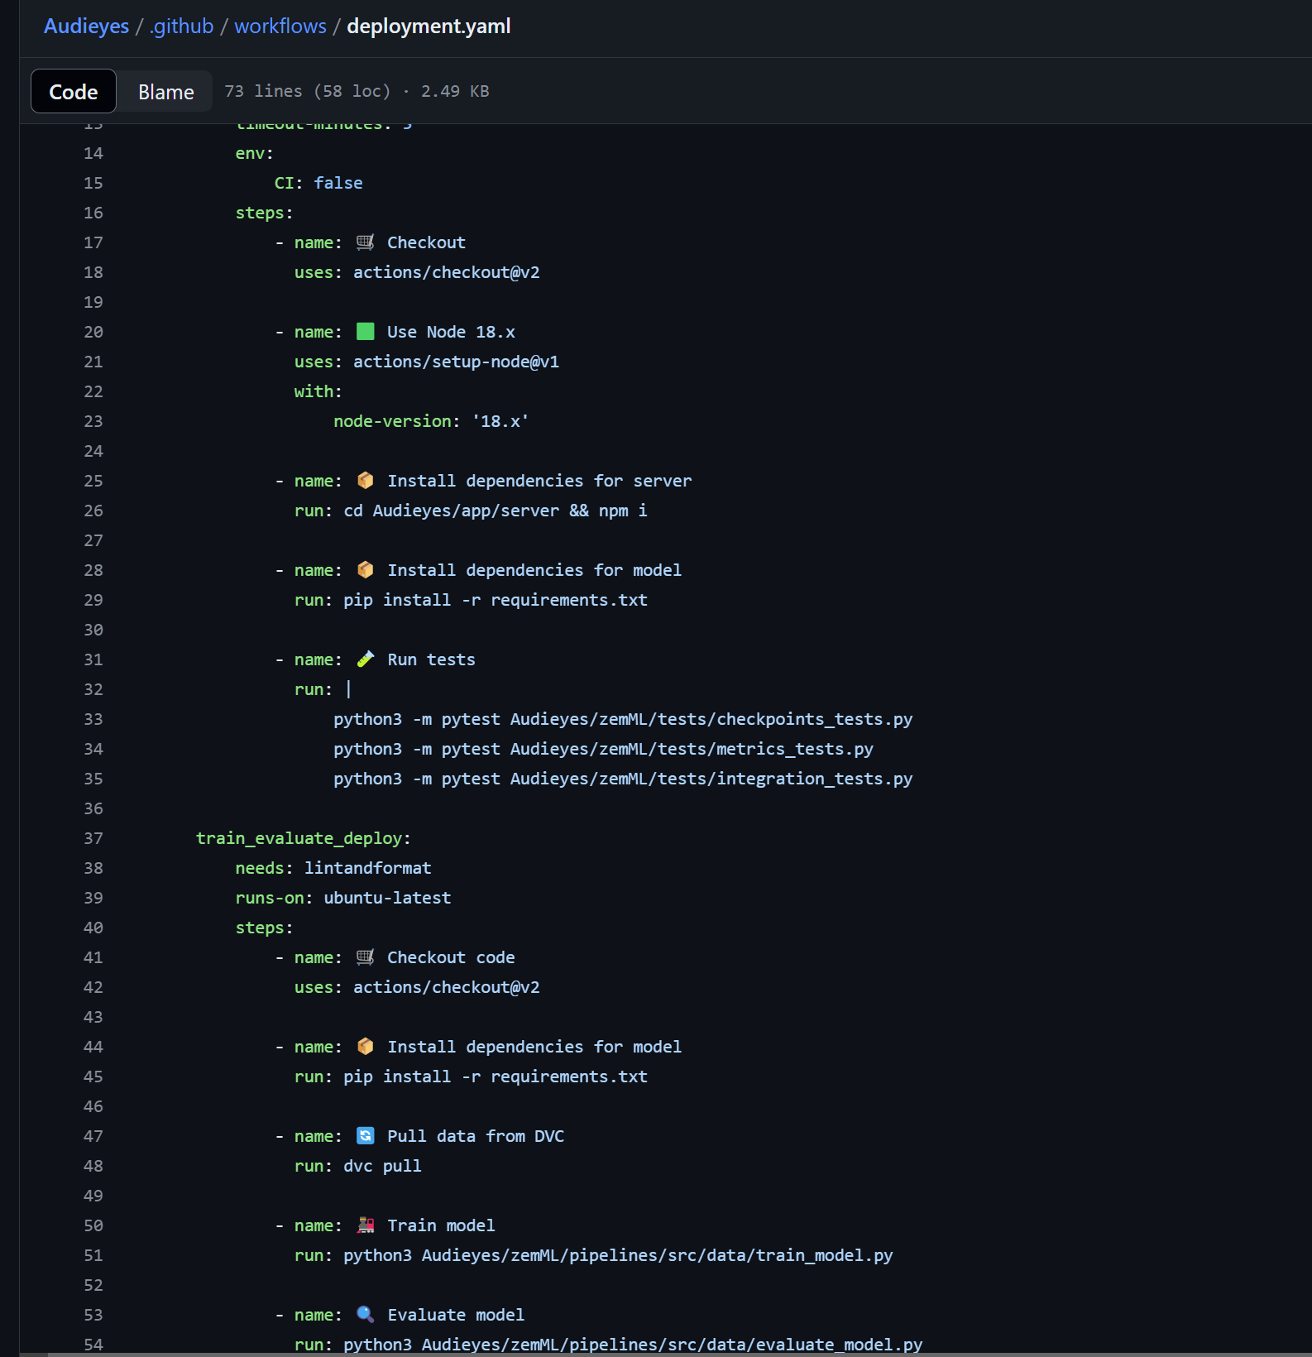

## 4.4. Pipeline Orchestration

# I have used GitHub Actions for pipeline orchestration, ensuring that the image captioning model is built, tested, and deployed automatically. I have used Cron Jobs to run the workflow at midnight on the first day of each month, ensuring that the model is updated regularly and remains up-to-date.

# 5. Responsible AI

**Evaluation Beyond Accuracy**

In the development and deployment of AI systems, ensuring the responsible use of technology is paramount. This includes evaluating models not just for their accuracy but also for their fairness, transparency, and potential biases. By auditing models for bias, we can identify and mitigate any unfair treatment of specific groups, ensuring that the technology benefits all users equitably.

**Audit Model for Bias**

To audit our image captioning model for bias, we use the Aequitas toolkit, an open-source bias and fairness audit tool designed to evaluate machine learning models. Aequitas helps us understand the fairness of our model by assessing its performance across different demographic groups and identifying any disparities.

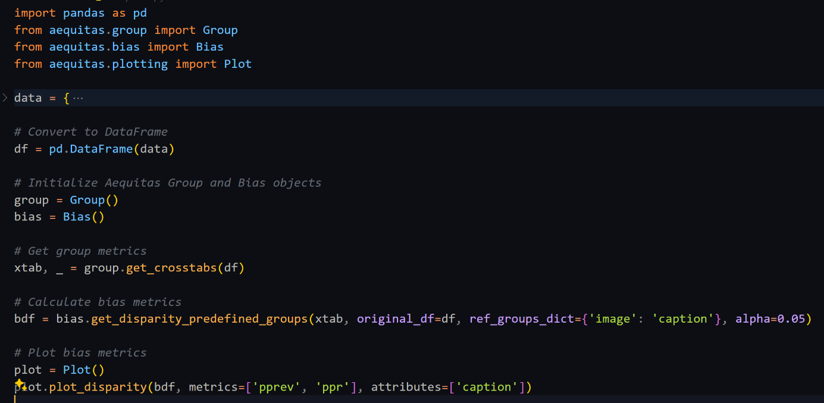

In this example, we use Aequitas to evaluate the disparity in model performance between different caption groups. We generate cross-tabulations of the model's performance metrics, calculate bias metrics, and visualize the results to understand any disparities.

By incorporating Aequitas into our workflow, we ensure that our model is evaluated for fairness and bias, promoting the development of responsible AI systems. This step is crucial for ensuring that the Audieyes project not only meets technical standards but also aligns with ethical considerations, ultimately providing equitable benefits to all users.

**Model Explainability and Interpretability**

Ensuring that our AI models are explainable and interpretable is crucial for building trust and transparency. Model explainability helps us understand how our models make decisions, which is essential for debugging, improving model performance, and ensuring fairness. By using tools like SHAP (SHapley Additive exPlanations) or LIME (Local Interpretable Model-agnostic Explanations), we can gain insights into the inner workings of our models and explain their predictions.

**Using SHAP for Model Explainability:** SHAP is a powerful tool for interpreting machine learning models. It provides consistent and interpretable explanations of the predictions made by the model by attributing the prediction to the input features.

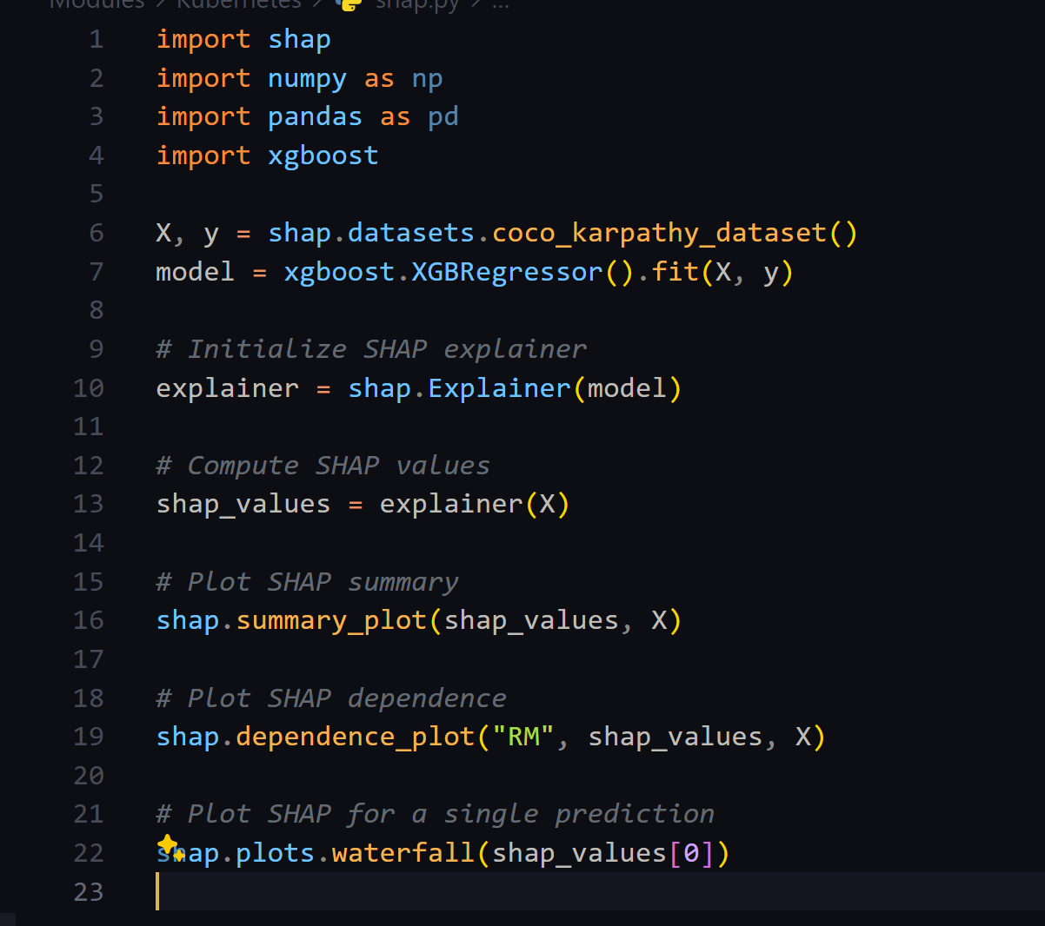

The summary plot provides a global view of feature importance, the dependence plot shows the effect of a single feature, and the waterfall plot explains the contribution of each feature to a specific prediction.

**Using LIME for Model Explainability:** LIME is another tool that explains the predictions of any machine learning classifier by approximating it locally with an interpretable model.

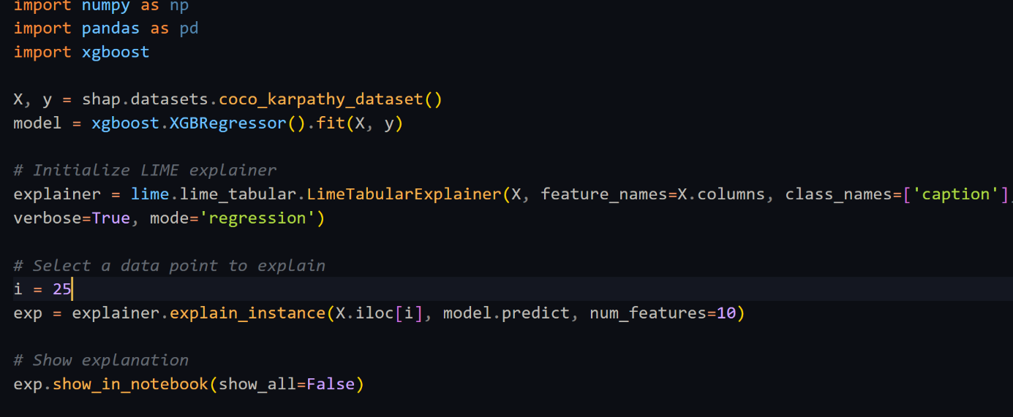

In this example, we:

* Load a sample dataset and train a simple model (replace this with your actual model and data).
* Initialize a LIME explainer for the model.
* Select a data point to explain.
* Generate and display the explanation for the selected data point.

LIME provides insights into which features are most influential for a specific prediction, making it easier to understand and trust the model's decisions.

By incorporating SHAP or LIME into our workflow, we ensure that our AI models are transparent and interpretable. This enhances trust and accountability, making it easier to debug and improve models while ensuring they align with ethical standards and provide fair and unbiased results.

# 6. Conclusion

* Summary of Achievements

In conclusion, the Audieyes project has made significant strides in enhancing accessibility for the visually impaired community through innovative technology. We've successfully integrated advanced machine learning models, like Salesforce's BLIP, into a user-friendly application, providing real-time, accurate descriptions of the visual world. Our deployment strategy using Docker, Linode, and Kubernetes has ensured that our services are both scalable and reliable.

The project not only stands as a testament to technological innovation but also reflects our commitment to inclusivity and responsible AI. Through rigorous bias audits and continuous improvement, I ensure that our solutions are equitable and accessible to all users. Overall, Audieyes represents a major leap forward in making every day navigation and interaction more accessible for those with visual impairments, truly embodying the potential of technology to transform lives.

* Lessons Learned

Throughout the development of the Audieyes project, several key lessons have been learned that have significantly shaped our approach and execution. One of the foremost insights was the importance of user-centered design in creating technology for visually impaired users. Early user feedback highlighted that what developers assumed would be intuitive was not always the case for the end users, underscoring the need for iterative design and frequent user testing to ensure the technology truly meets the needs of its intended users.

W I e also learned the critical role of robust data management, particularly in ensuring data quality and diversity. Initial models showed biases because the training datasets were not representative of the diverse range of users who would interact with the system. This led to a comprehensive overhaul of our data collection and preprocessing stages, emphasizing the inclusion of a broader array of inputs to train more equitable and effective models.

Another significant lesson was about the scalability and flexibility of the technological infrastructure. As the project scaled, the initial setups struggled to handle increased loads efficiently. Adopting a microservices architecture, leveraging cloud services like Linode, and orchestrating our services with Kubernetes allowed us to manage scaling more dynamically and maintain performance regardless of user demand.

These lessons have not only improved the Audieyes project but have also provided valuable insights that I can carry forward into our future thesis work but this time using the approach of LLMs, ensuring I build more performing, scalable, and unbiased AI projects.

* Future Directions

As I look to the future of the Audieyes project, there are several exciting directions I aim to explore to enhance our system's capabilities and impact. One of the key areas I plan to delve into involves leveraging large language models (LLMs) to improve the descriptive accuracy and contextual relevance of our image and video captioning features. By integrating LLMs, I anticipate significant advancements in the system's ability to generate more natural and detailed descriptions, which will be particularly beneficial for visually impaired users in understanding their surroundings better.

Furthermore, I are considering the potential of expanding our technology to include predictive analytics, which could forecast potential obstacles or necessary actions based on the user’s environment and habitual patterns. This predictive feature could offer proactive assistance, enhancing safety and convenience for our users.

In addition to technical enhancements, I plan to use the Audieyes project as a cornerstone for our thesis. This will involve a detailed analysis of the implementation and impact of our system, emphasizing how innovative technologies like LLMs can revolutionize accessibility tools. Our thesis will document the challenges, solutions, and successes of developing Audieyes, providing a comprehensive case study on the application of cutting-edge AI technologies in real-world scenarios aimed at improving quality of life for individuals with visual impairments. This academic endeavor will not only contribute to our personal academic goals but also to the broader field of AI and accessibility, showcasing practical implementations and the transformative potential of AI.

# References

Junnan Li, D. L. (2022 , Jan 28 ). BLIP: Bootstrapping Language-Image Pre-training for Unified Vision-Language Understanding and Generation.